I-9 Management Reports User Guide

Revised: July 2017

# Table of Contents

Overview 4

Compliance Start Date 4

I-9 Retention 4

Reporting Capabilities 5

Report Output 7

Accessing Reports 7

Accessing Reports Standard Reports 12

Standard Reports 12

All I-9 Data Report 13

All I-9 Report Version 2 13

Transaction Statistics 13

I-9 Billable Transaction 14

Employee Search 15

Conversion Error 15

Uploaded Images 16

E-Verify Case Status 16

Alien Employees 18

Employee Audit 19

I-9 Users 20

CO Affirmation Employees 21

E-Verify Photo Matching 22

E-Verify State Audit 23

I-9 Gap 24

Custom Reports 24

Automated Reports 25

Automated All I-9 Report 25

Automated E-Verify Case Tracking 29

Automated Pending I-9 Report 30

Automated Missing I-9 Report 31

Compliance Reports 33

Compliance Summary 33

Compliance Summary Calculations 34

Missing Payroll 34

Missing I-9 35

Invalid SSN 36

Search Capabilities 36

Quick Search “Pending” 36

Quick Search Access 37

Employee Search 39

Employee Search Access 40

Export to Excel 42

Type of Form I-9 43

# Overview

The purpose of this document is to provide a description and examples of the reports available through the Equifax I-9 management service. Please note that some reports are only available to employers who also subscribe to The Work Number, the Equifax employment verification service. For security and clarity, reports are only available to a user if the user’s role includes reports and the reports only contain data from locations the user is authorized to access.

## Compliance Start Date

The I-9 service utilizes a Compliance Start Date, which is defined in the client’s service configuration. This date allows employers to configure a date which indicates when the employer began using the I-9 service. Employers can measure compliance on a go forward basis from this date. This allows employers to only include employees who meet the following criteria:

* Employees hired on or after the Compliance Start Date and do not have a termination date in The Work Number.
* Employees hired on or after the Compliance Start Date, have a termination date in The Work Number, and their hire and termination dates coupled with the current date fall within the Form I-9 retention requirements, described below.

## I-9 Retention

Only employees hired after November 6, 1986 (November 7, 1986 and forward) are required to have a Form I-9 on file.

Employers must retain completed Forms I-9 for 3 years after the date of hire or 1 year after the date employment ends, whichever is later. If an employee works for 1 year and terminates the Form I-9 must be retained for 2 more years to meet the 3 year minimum. If an employee works for 5 years and terminates, the Form I-9 must be retain for 1 more year.

Below is form provided by the USCIS that employers can use to calculate when an employee’s I-9 may be purged.



Handbook for Employers, Instructions for Completing Form I-9 (M-274) - Figure 8, page 23

The employee hire date and Form I-9 retention rule are presented in the following table of possible outcomes for a given employee.

|  |  |  |
| --- | --- | --- |
|  | **Active Employee**  **(hired after November 6, 1986)** | **Terminated Employee**  **(subject to retention requirements)** |
| **No I-9 on file** | Not Compliant | Not Compliant |
| **Active I-9 on file** | Compliant | Compliant |
| **Expired I-9** | Not Compliant | If Term Date < Expired Date, Compliant |

# Reporting Capabilities

There are three types of reports available; Standard, Automated, and Compliance.

* **Standard** – these reports are available to all employers using the service and do not rely on any other Equifax services for additional information.
* **Custom** – these reports are available to all employers using the service and do not rely on any other Equifax services for additional information.
* **Automated** – these reports are generated automatically and posted for pickup on either the Equifax or your FTP site. These reports are generated on a pre-defined schedule.
* **Compliance** – these reports are available to employers that provide payroll data to The Work Number to automate employment verifications. These reports combine payroll data from The Work Number and the Forms I-9 on file. You must have the Compliance feature on in order for these reports to be available.

Standard and Compliance reports are accessible through the I-9 service by clicking the **Reports** link on the **Main Menu**. Reports are obtained on a subscription basis, which means that you schedule a report to be generated in the future (select date time for report generation). When scheduling, you name the report and enter your e-mail address. An e-mail is sent to you when the report is available for pickup. The following sections provide details for all reports available through the Report Provider.

|  |  |  |
| --- | --- | --- |
| **Report Name** | **Report Description** | **Format** |
| Alien Employees | All employees attesting to alien in Section 1 | CSV/Excel/PDF/Word |
| All I-9 | Data on all completed Forms I-9 | CSV/Excel |
| CO Affirmation Employees | Eligible employees without the CO Affirmation Form on file | CSV/Excel/PDF/Word |
| Compliance Summary | Results of comparing the Form I-9 and The Work Number databases | CSV/Excel/PDF/Word |
| Conversion Errors | All converted Forms I-9 with missing and/or incorrect indexing data | CSV/Excel/PDF/Word |
| Employee Audit Data | Form I-9 audit trail data for one or more employees | CSV/Excel/PDF/Word |
| Employee Search | More detailed data than is available using the Employee Search page | CSV/Excel |
| E-Verify Case Status | Employees that have not been Employment Authorized by E-Verify | CSV/Excel/PDF/Word |
| E-Verify Photo Matching | Photo matching cases that do not meet document retention requirements | CSV/Excel/PDF/Word |
| E-Verify State Audit | E-Verify case information for employees in a State, Group, or Location | CSV/Excel/PDF |
| I-9 Gap | Indicates if a Form I-9 exists for up to 5,000 SSNs | CSV/Excel/PDF/Word |
| I-9 Users | List of all authorized users | CSV/Excel/PDF/Word |
| Invalid SSN | All Forms I-9 with SSN marked as invalid | CSV/Excel/PDF/Word |
| Missing I-9 | Employees without a Form I-9 on file | CSV/Excel/PDF |
| Missing Payroll | Employees with a Form I-9 on file, but not a record in The Work Number | CSV/Excel/PDF/Word |
| Transaction Statistics | Listing of user transactions during a defined period of time | CSV/Excel/PDF/Word |
| Uploaded Images | All uploaded Forms I-9 and attached documents | CSV/Excel/PDF/Word |

## Report Output

The user must choose the desired report format. Formats are chosen by the user on the **Report Selection** screen. See the list above for the available output format for each report.

* **CSV Reports** – suitable for reports that may generate large amounts of tabular data. The data can be used to create custom reports using a tool such as Microsoft Excel. The data can also be used to update backend employer systems.
* **Excel Reports** – suitable for reports that may generate large amounts of tabular data. The data can be used to create custom reports.
* **PDF Reports** – suitable for small amounts of data that will be displayed in user friendly format. PDF reports are formatted and have a page number in the bottom right hand corner (format: x of y). Multi-page PDF reports have the report name at the top of each page after the first page, which contains the report header. Column headers also appear on each page.
* **Word Reports** – suitable for small amounts of data that will be displayed in user friendly format. Word reports are formatted and have a page number in the bottom right hand corner (format: x of y). Multi-page Word reports have the report name at the top of each page.

# Accessing Reports

All reports are accessed through the I-9 service. Authorized users have access to the **Reports** via the link on the left menu which is displayed on each page in the site.

Click the **Reports** link to access the report provider page where you can manage your reports. The reports available to you are based on your User Role as well as whether or not your employer provides payroll data to The Work Number (Equifax employment and income verification service).

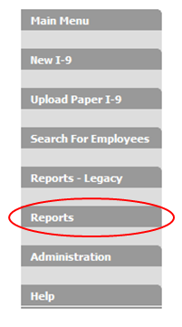

**Note:** “Reports – Legacy” is the legacy reports platform. The legacy platform was replaced in 2014, and was retired in early 2015.

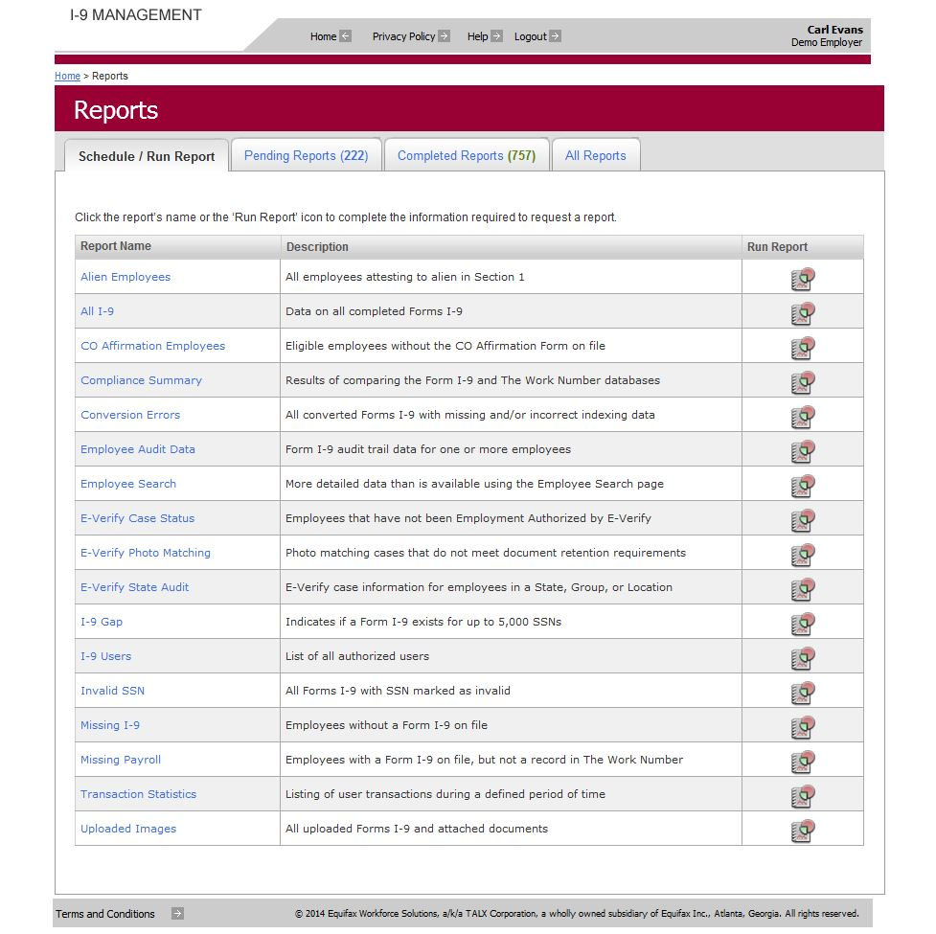

* Request a new report from the **Schedule/Run Report** tab**,**
* View reports you have requested in the **Pending Reports** tab, or
* Pick up a finished report from the **Completed Reports** tab.
* View a list of all completed and pending reports in the **All Reports** tab.

## Example Report Parameters Screen

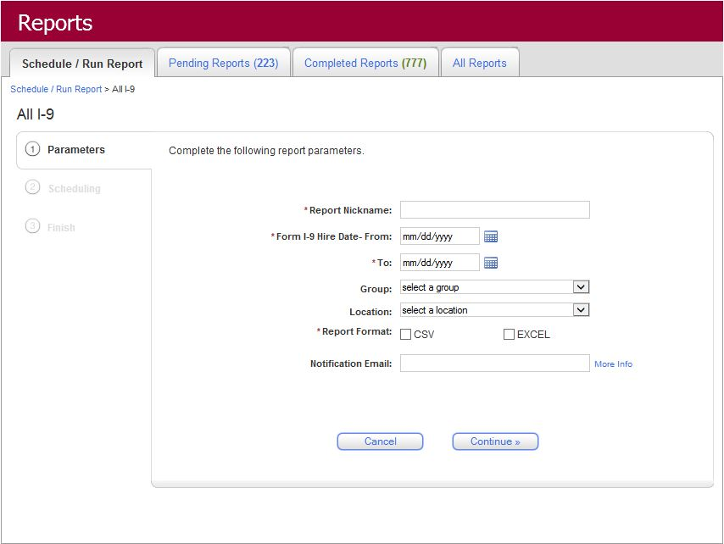

## Example Scheduling Screen

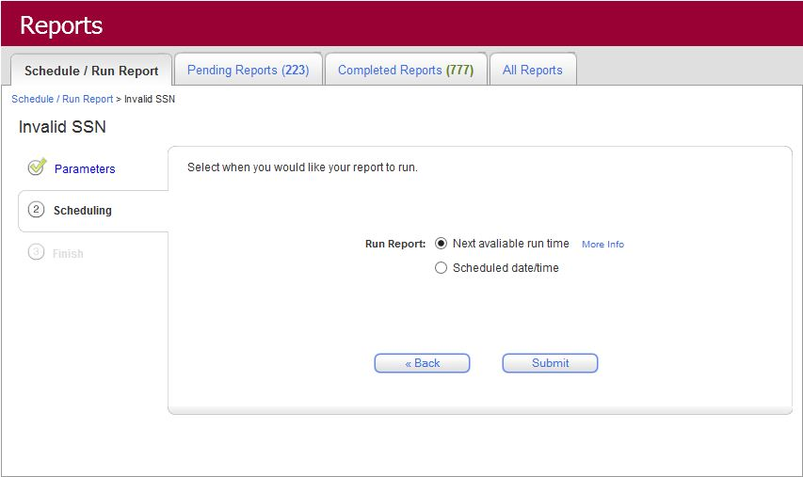

* Selecting **“Next available run time”** will generate your report at the next available run time (typically 5 minutes after the report request is submitted).
* Selecting **“Schedule date/time”** will allow you to schedule you report for a future date and time.

## Example Finished Report Request Screen

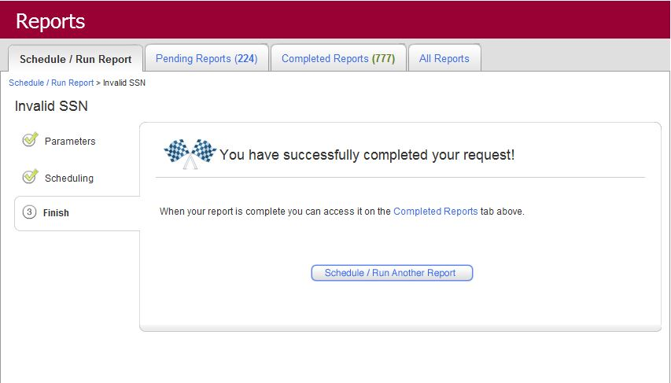

# Accessing Reports Standard Reports

All reports are accessed through the I-9 service. Authorized users have access to the **Reports** via the link on the left menu which is displayed on each page in the site.

Click the **Reports** link to access the report provider page where you can manage your reports. The reports available to you are based on your User Role as well as whether or not your employer provides payroll data to The Work Number (Equifax employment and income verification service).

**Note:** “Reports – Legacy” is the legacy reports platform. The legacy platform was replaced in 2014, and was retired in early 2015

# Standard Reports

This section provides directions for creating and interpreting the Standard reports. Standard reports are available to authorized users for all employers.

There are several types of Standard reports:

* **All I-9**
* **All I-9 Report Version 2**
* **Transaction Statistics**
* **Billable I-9 Transactions**
* **Employee Search**
* **Conversion Errors**
* **Uploaded Images**
* **E-Verify Case Status**
* **Alien Employees**
* **Employee Audit Data**
* **I-9 Users**
* **CO Affirmation Employees**
* **E-Verify Photo Matching**
* **E-Verify State Audit**
* **I-9 Gap**

## All I-9 Data Report

* **Availability** – This report is available to every client.
* **Report Description** – The report contains the data for all completed Forms I-9 on file. The report is used to list all Forms I-9 added for the specified locations during a given time period. The report is also used to create custom reports and as a data feed to other systems.
* **Report Format** – The report is available in CSV and Excel formats.
* **Report Parameters** – Set when the user requests the report:
  + Begin Date – The report contains all Forms I-9 added starting on this date.
  + End Date – The report does not contain any Forms I-9 added after this date.
  + Location Selection – The report includes data from either a single location or all locations the user is authorized to access. The available locations are only those the user is authorized to access. **ALL** represents all locations the user is authorized to access.
* **Report Contents** – Each row of the report contains the following information (columns) from left to right for each Form I-9 on file. Output rows are sorted first by employee SSN and then by the Form I-9 completion date. The report contains all columns regardless of your specific configuration. This means that even if you do not use E-Verify, the columns for E-Verify information are still present.
* When a new Form I-9 is added, a new row is created in the report.
* When Section 3 is completed, a new row is created in the report.



## All I-9 Report Version 2

* **Availability** – This report is available to every client.
* **Report Description** – The report provides a list of all Form I-9 activity during a defined period of time. However, this report provides the information in a format that is easier to follow.
* **Report Format** – The report is available in CSV and Excel.
* **Report Parameters** – Set at the time the user requests the report.
  + Month/Year– Possible options are a single month and a four-digit year.
* **Report Contents –** Each row of the report contains the information (columns) listed below from left to right for each Form I-9 on file. Rows are alphabetically sorted by year/month, location code, and location name.



## Transaction Statistics

* **Availability** – This report is available to every client.
* **Report Description** – The report provides a list of all Form I-9 activity during a defined period of time.
* **Report Format** – The report is available in CSV, Excel, PDF and Word format.
* **Report Parameters** – Set at the time the user requests the report.
  + Month/Year – Possible options are a single month and a four-digit year.
* **Report Contents** – Each row of the report contains the information (columns) listed below from left to right for each Form I-9 on file. Rows are alphabetically sorted by year/month, location code, and location name.
  + Year/Month
  + Location Code
  + Location Name
  + Transaction Type Description
  + Media Type Description
  + Count



## I-9 Billable Transaction

* **Availability** – This report is available to every client.
* **Report Description** – The report allows users to view all billable transactions and associated transactions level detail
* **Report Format** – The report is available in CSV, Excel, PDF and Word format.
* **Report Parameters** – Set at the time the user requests the report.
* Month/Year – Possible options are a single month and a four-digit year.
* **Report Contents** – Each row of the report contains the information (columns) listed below from left to right for each Form I-9 on file. Rows are alphabetically sorted by year/month, location code, and location name.
  + Location Code
  + User ID
  + User Defined Field- Determined by the Employer System Configurations
  + Last 4 of SSN
  + Transaction type
  + EE Last Name



## Employee Search

* **Availability** – This report is available to every client. It is only available to users authorized to access the Excel Export feature on the Search for Employees page.
* **Report Description** – The user can generate a report using the same criteria available on the Search for Employees page.
* **Report Format** – The report is only available in CSV and Excel format.
* **Report Parameters** – Optional report criteria listed below can be set when the user requests the report to narrow the search results.
  + First Name – Employee first name.
  + Last Name – Employee last name.
  + SSN – Employee SSN.
  + Type of I-9 – e.g., pending, missing, reverification, SSN applied for, E-Verify issue.
  + Employment Date – Employment date in Section 2 of Form I-9.
  + Group/Location – Include Forms I-9 for a specific group or location.
  + Active/Terminated – Include Forms I-9 for active and/or terminated employees. This option is only available if you provide payroll data to **The Work Number**.
* **Report Contents** – Each row of the report contains the information (columns) listed below from left to right for each Form I-9 on file.



## Conversion Error

* **Availability** – This report is available to clients that converted Forms I-9 prior to August 2016 and have the option enabled.
* **Report Description** – The report contains data for all converted Forms I-9 that contain one or more errors. An authorized user can correct or accept the errors via the Edit Data option on the Employee Detail page to remove the Forms I-9 from the report.
* **Report Format** – The report is only available in CSV, Excel, PDF and Word format.
* **Report Parameters** – The report contains all conversion errors.
* **Report Contents** – Each row of the report contains the information (columns) listed below from left to right for each converted Form I-9 that contains errors.
  + Employee Name (First and Last)
  + Employee SSN
  + Employee Location



## Uploaded Images

* **Availability** – This report is only available if you have the Upload I-9 or the Attach File features enabled.
* **Report Description** – The report contains data for all Forms I-9 added using the Upload I-9 feature. The report also includes any files that have been attached to completed Forms I-9 using the Attach File feature. Use this report to monitor and inventory uploaded Forms I-9 as well as attached documents.
* **Report Format** – The report is only available in CSV, Excel, PDF and Word format.
* **Report Parameters** – The report is a list of all uploaded Forms I-9 and documents attached to Forms I-9 on file.
* **Report Contents** – Each row of the report contains the information (columns) listed below from left to right for each uploaded Form I-9 or attachment on file.
  + Location (Employee Location)
  + Document Name (Uploaded Forms I-9 = I-9, Attach Document = User Defines Name)
  + Transaction Date (Date I-9 or document added to the I-9 service)
  + SSS User Name (Name of the user that Uploaded the I-9 or attached the document)
  + First Name (Employee)
  + Last Name (Employee)
  + Middle Initial (Employee)
  + SSN (Employee)



## E-Verify Case Status

* **Availability** – This report is only available if you use E-Verify.
* **Report Description** – The report is the list of employees that have not been **Employment Authorized** by E-Verify.
* **NOTE:** The report only includes employees who have:
  + Not submitted to E-Verify, or
  + NOT **Employment Authorized** by E-Verify (i.e., E-Verify cases closed as E**mployee Self Terminated**, **Unauthorized Employee Terminated**, and **Invalid Query**.
  + Employees resolved as **Employment Authorized** or with an open E-Verify case are NOT included in the report.
* **Report Format** – The report is only available in CSV, Excel, PDF and Word format.
* **Report Parameters** – The report parameters to filter the results are listed below and are selected when the report is requested.
  + **Start Date / End Date** – The report only includes employees hired within the selected date range.
  + **Group** – Filter the report contents to only include employees in the specified group. The default setting is ALL.
  + **Location** – Filter the report contents to only include employees from the specified location. The default setting is ALL.

**NOTE:** If you select a group AND a location, the report will include employees in the selected group and in the selected location. This means that you can specify a location that is not in the group you specify.

* + **FAR Locations Only** – If the checkbox is checked, the report only includes employees assigned to locations configured as FAR Locations. By default the checkbox is NOT checked.
  + **Filter Employees** – Select one of the following filter options to specify the type of employees to include in the report.
    - **All Employees (default setting)**
    - **Employees with a Form I-9 on file**
    - **Employees without a Form I-9 on file**
    - **Employees with a Not Authorized E-Verify status**
* **Report Contents** – The report is divided into three sections, Header, Summary, and Detail. Below is description of these sections.
* **Report Header** – Labeled E-Verify Employee Status Report. This section includes a summary of the user’s parameters as well as the Employer Name, Employer Code, and Creation Date for the report.
* **Report Summary** – Labeled E-Verify Employee Summary. This section includes a summary view of the number of employees Not Authorized by E-Verify. Below is a list of the information (columns) and an explanation of how totals are calculated.
  + Group Code
  + Group Name
  + Location Code
  + Required – The count of all active employees in an E-Verify Location with a Hire Date after November 6, 1986.
  + Submitted – The count of all employees that meet one of the following criteria:
    - Have a Form I-9 on file that has been submitted to E-Verify, or
    - Have no Form I-9 on file, but do have an E-Verify record on file. This is the case when:
      * An employee was manually submitted to E-Verify using the E-Verify website and the E-Verify case information was obtained from the E-Verify User Audit Report, or
      * When the employee was submitted to E-Verify by another Employer Agent (EA, formerly Designated Agent) and the E-Verify case information was provided by the other EA.
  + Not Submitted – Count all Required employees NOT sent to E-Verify.
  + Data Ready – Count of Forms I-9 marked Ready for E-Verify. (Federal Contractors only)
  + Not Data Ready – Count of Forms I-9 NOT marked Ready for E-Verify. (Federal Contractors only)
  + No I-9 or E-Verify – Count of Required employees without a Form I-9 on file (i.e., Missing I-9) or without an E-Verify status.
  + Totals – Totals of each column provides a view for all locations combined.
  + Calculations:

Submitted + Not Submitted = Required

Data Ready + Not Data Ready + (No I-9 or E-Verify) = Not Submitted

* **Report Detail** – Labeled **E-Verify Employee Detail**. This section is a detailed listing of all employees in the report. Below is a list of the information (columns) in this section.
  + Group Code
  + Group Name
  + Location Code
  + Location Name
  + FAR Location (Y/N) – Indicates if the Form I-9’s location is a FAR Location.
  + SSN
  + First Name
  + Last Name
  + MI
  + I-9 Employment Date
  + TWN Most Recent Hire Date – TWN refers to The Work Number.
  + I-9 On File (Y/N)
  + Data Ready (Y/N)
  + FAR E-Verify Status – Covered or Not Covered, based on the location’s configuration.
  + Company ID Number – The employer’s E-Verify Company ID number.



## Alien Employees

* **Availability** – This report is available to all clients and lists employees with a current Form I-9 indicating the employee is an alien.
* **Report Description** – The report contains data for all alien Forms I-9.
* **Report Format** – The report is only available in CSV, Excel, PDF and Word format.
* **Report Parameters** – The report contains all Forms I-9 for aliens.
* **Report Contents** – Each row of the report contains the information (columns) listed below from left to right for each employee whose current Form I-9 indicates the employee’s citizenship status is Alien Authorized to Work.
  + Group
  + Location
  + First Name
  + Middle Initial
  + Last Name
  + SSN
  + Citizenship Status
  + Work Authorization Expiration Date
  + Employment Date
  + Current E-Verify Status



## Employee Audit Data

* **Availability** – This report is available to all clients.
* **Report Description** – The report contains data for all The purpose of the Audit Report is to track the addition of I-9s as well as any edits or changes made to the employee’s I-9 including a description of the event, the time and date of the event and the name of the person that performed the event. The electronic I-9 rules published in the Federal Register require that employers record an audit trail to track these items. Employers must also retain the audit trail and be able to provide the information to the government if requested as part of an I-9 audit.
* In December 2010 the Audit Report in the I-9 service was enhanced to include addition information. First, personal employee data was added to allow employers identify the employee that the Audit Report relates to if the report is viewed outside of the I-9 service (e.g., employee’s name, last 4 digits of the SSN and date of birth). Second, Pending I-9 data was added to the Audit Report to track the completion of Section 1.
* Prior to the January 2011 enhancement, the Audit Report was only accessible to users by clicking the Audit Report link on the Employee Detail page in the I-9 service. Clicking the link generates the Audit Report for this employee.
* **Report Format** – The report is only available in CSV, Excel, PDF and Word format.
* **Audit Report for Multiple Employees**

The January 11, 2011 enhancement is the next phase of updates to the compliance reporting tools. This update provides authorized users the ability to generate an Audit Report that includes data for multiple employees. This makes it easier for employers to review audit data for a group employees, and in turn, respond to an auditors request for audit trail data.

* **Generating an Audit Report for Multiple Employees**

The new report option is available to users via the Reports feature in the I-9 service. When requesting the Audit Report via the Report provider, employers may generate an Audit Report to include all employees in a specific Group or Location, or employers can enter SSNs of employees they wish to include.

* + Below are the steps to request the Audit Report for multiple employees.
    1. Click the “Reports - Beta” link in the I-9 service (displayed for authorized users only).
    2. Click the “Employee Audit Data” link.  
         
       
    3. Enter the desired parameters and follow the onscreen prompts to request the report. You may filter the report using the following parameters:
       1. Date Range (hire date)
       2. Active/Terminated Employees
       3. Filter by a single Group or Location (default is ALL for both).
       4. List of SSNs for employees that you wish to include in the Audit Report (100 = Maximum number of SSNs per report)
    4. Return to the Reports feature to retrieve the report when you receive the notification that the report is ready.
* **Entering a List of SSNs**

If you enter a list of employee SSNs, they must be separated by a comma and it is best to enter one SSN per row. To type the SSNs in the Report Provider, enter the SSN followed by a comma, then hit the “Enter” key on your keyboard to move to the next line. Do not include spaces. Another option is to enter the data in Excel or Notepad and copy and paste into the parameters page. If you cut and paste you must still follow the format of SSN/comma/carriage return.

* + Data Format Example:

123456789,

123456780,

123456781,

Note: If you need an Audit Report for only one employee, accessing the Employee Detail page and clicking the Audit Report link is the best option.



## I-9 Users

* **Availability** – This report is available to every client.
* **Report Description** – The report provides a list of all authorized users.
* **Report Format** – The report is available in CSV, Excel, PDF and Word format.
* **Report Parameters** – Set at the time the user requests the report.
  + **Group** – Filter the report contents to only include employees in the specified group. The default setting is ALL.
  + **Location** – Filter the report contents to only include employees from the specified location. The default setting is ALL.

**NOTE:** If you select a group AND a location, the report will include employees in the selected group and in the selected location. This means that you can specify a location that is not in the group you specify.

* + **User Last Name –** You may choose to only include specific users by Last Name.
  + **User Id –** You may choose to only include specific users by User ID.
  + **User SSN –** You may choose to only include specific users by SSN.
  + **User Role –** You may choose to only include specific users by Use Role.
  + **Add Termination Date --** You may choose to include employee termination dates**.**
* **Report Contents** – Each row of the report contains the information (columns) listed below from left to right for each Form I-9 on file. Rows are alphabetically sorted by year/month, location code, and location name.
  + User ID
  + SSN
  + First Name
  + Last Name
  + Creation Date Time
  + Role
  + Role Level
  + Action Date
  + Action Desc
  + Action Target Location
  + System Last Action Date
  + Termination Date



## CO Affirmation Employees

* **Availability** – This report is available to every client.
* **Report Description** – The report provides a list of eligible employees without the CO Affirmation Form on file.
* **Report Format** – The report is available in CSV, Excel, PDF and Word format.
* **Report Parameters** – Set at the time the user requests the report.
  + **Form I-9 Hire Date – From/To** – In mm/dd/yyyy format.
  + **Group** – Filter the report contents to only include employees in the specified group. The default setting is ALL.
  + **Location** – Filter the report contents to only include employees from the specified location. The default setting is ALL.

**NOTE:** If you select a group AND a location, the report will include employees in the selected group and in the selected location. This means that you can specify a location that is not in the group you specify.

* + **Employee Type** – Choose Active Only, Terminated Only or Active and Terminated.
  + **Include –** You can choose to include Active (most current) I-9s Only.
* **Report Contents** – Each row of the report contains the information (columns) listed below from left to right for each Form I-9 on file. Rows are alphabetically sorted by year/month, location code, and location name.
  + Location Code
  + Location Name
  + Location State
  + Date Since Hire
  + CO Eligible
  + CO Complete
  + All Documents Attached
  + Employee Last Name
  + Employee First Name
  + Employee MI
  + Employee State
  + Last 4 SSN
  + Hire Date
  + I-9 Employer Signature
  + I-9 Employer Last Name
  + I-9 Employer First Name
  + CO Employer Signature
  + CO Employer Last Name
  + CO Employer First Name



## E-Verify Photo Matching

* **Availability** – This report is available to every client.
* **Report Description** – The report provides a list photo matching cases that do not meet document retention requirements.
* **Report Format** – The report is available in CSV, Excel, PDF and Word format.
* **Report Parameters** – Set at the time the user requests the report.
  + **Form I-9 Hire Date – From/To** – In mm/dd/yyyy format.
  + **Group** – Filter the report contents to only include employees in the specified group. The default setting is ALL.
  + **Location** – Filter the report contents to only include employees from the specified location. The default setting is ALL.

**NOTE:** If you select a group AND a location, the report will include employees in the selected group and in the selected location. This means that you can specify a location that is not in the group you specify.

* **Employee Type** – Choose Active Only, Terminated Only or Active and Terminated.
  + **Include –** You can choose to include Active (most current) I-9s Only.
* **Report Contents** – Each row of the report contains the information (columns) listed below from left to right for each Form I-9 on file. Rows are alphabetically sorted by year/month, location code, and location name.
  + Year/Month
  + Location Code
  + Location Name
  + Transaction Type Description
  + Media Type Description
  + Count



## E-Verify State Audit

* **Availability** – This report is available to every client.
* **Report Description** – The report provides a list of all E-Verify case information for employees in a State, Group, or Location.
* **Report Format** – The report is available in CSV, Excel, and PDF and format.
* **Report Parameters** – Set at the time the user requests the report.
  + **Form I-9 Hire Date – From/To** – In mm/dd/yyyy format.
  + **Group** – Filter the report contents to only include employees in the specified group. The default setting is ALL.
  + **Location** – Filter the report contents to only include employees from the specified location. The default setting is ALL.

**NOTE:** If you select a group AND a location, the report will include employees in the selected group and in the selected location. This means that you can specify a location that is not in the group you specify.

* + **State** – You may only choose ONE state per report.
* **Report Contents** – Each row of the report contains the information (columns) listed below from left to right for each Form I-9 on file. Rows are alphabetically sorted by year/month, location code, and location name.
  + Company ID Number
  + Company Name
  + City
  + State
  + Location Name
  + Initiated By
  + Case Verification Number
  + Employee First Name
  + Employee MI
  + Employee Last Name
  + Group Code
  + Location Code
  + Location Name
  + IS Group
  + First Name
  + Last Name
  + SSN
  + Signature Date
  + Signer Name
  + Date Added
  + Employee Status
  + Attachments Exist
  + Copy Retained



## I-9 Gap

* **Availability** – This report is available to every client.
* **Report Description** – The report indicates if a Form I-9 exists for up to 5,000 SSNs.
* **Report Format** – The report is available in CSV, Excel, PDF and Word format.
* **Report Parameters** – Set at the time the user requests the report.
  + **SSN –** List SSNs to include on report, without dashes.
* **Report Contents** – Each row of the report contains the information (columns) listed below from left to right for each Form I-9 on file. Rows are alphabetically sorted by year/month, location code, and location name.
  + Location
  + Status
  + SSN
  + First Name
  + Last Name
  + I-9 Entry Date
  + I-9 Hire Date
  + E-Verify Status



# Custom Reports

This section provides directions for creating and building a custom report. Custom reports are available to authorized users for all employers.

To create a Custom Report, you will need to navigate to “Custom” using the toggle button in the upper right hand corner. You will then have the ability to create a report based on the available data elements that you would like to incorporate for your reporting needs. Once you report has been created, you can run your report based on certain parameters that are available.

* **Availability –** This concept is available to all clients.
* **Report Description –** This report is customizable based on your needs.
* **Report Format –** This report is available in Excel or CSV
* **Report Parameters –** Set at the time the user requests the report.
* Pre-defined date ranges: A drop down list of options will be made available to the end user. The drop down list will contain multiple options such as, but not limited to the following:
  + Prior Day – Previous day’s activity (calendar day)
  + Current Week – Current week’s activity (Sunday – Saturday)
  + Prior Week – Prior week’s activity (Sunday – Saturday)
  + Prior Month – Prior month’s activity (1st calendar day to last calendar day)
  + Rolling 12 Months – Previous 12 calendar month’s activity
* User defined date ranges: An open field allowing the user to identify their specific date ranges:
  + From field – Open field allowing user to identify their begin date
  + To field – Open field allowing user to identify their end date
* **Report Contents –** The contents of this report are customizable based on your needs.

**NOTE: For more information on how to create and run a Custom Report, please see our **Custom Report User Guide.**

# Automated Reports

This section provides directions for creating and interpreting reports generated automatically outside of the **Report Provider**. Automated reports are automatically generated using a pre-defined schedule.

There are several types of Automated reports:

* All I-9
* E-Verify Case Tracking
* Automated Pending I-9 Report
* Automated Missing I-9 Report

## Automated All I-9 Report

The All I-9 report can be generated automatically based on a pre-defined schedule. When generated, the report is encrypted and posted on the Equifax FTP site for you to pick up.

### Scheduling Options

The Automatic generation of the All I-9 report can be scheduled to run using one of the options listed below. The options include the ability to run the report on a regular basis (daily, weekly, or monthly) or it can be scheduled to run periodically (multiple times throughout the day) depending on your needs.

The All I-9 reports are executed as close as possible to the requested time based on other activities scheduled at the same time. The client is able to run regularly scheduled reports and periodic reports.

* Regularly scheduled reports:
  1. Daily – The report is run once per day at a requested time. The report includes all Forms I-9 created in the preceding day from 12:00 a.m. through 11:59 p.m. So, if you run the daily report on Tuesday at 8:00 a.m., the report includes all the Forms I-9 created the prior day (Monday) from 12:00 a.m. – through 11:59 p.m.
  2. Weekly – The report is scheduled to run once per week at a requested time. The report includes all Forms I-9 created during the preceding week from 12:00 a.m. Monday morning through 11:59pm Sunday. So, if the weekly report runs on Tuesday at 8:00 a.m., the report includes all Forms I-9 created the prior week (Monday through Sunday) from 12:00 a.m. Monday through 11:59 p.m. Sunday.
  3. Monthly – The report can be run once per month at a requested time. The report includes all Forms I-9 created during the preceding month from 12:00 a.m. on the first day of the month through 11:59 p.m. on the last day of the month. So, if you run the report monthly on the third day of the month at 8:00 a.m., the report includes all Forms I-9 created the prior month from 12:00am on the first day of the month through 11:59pm on the last day of the month.
* Periodic report during a day:
  1. Request the report a number of times per day. The options for this value are – 2, 3, 4, 5 or 6. The number of times per day and hours must not exceed a 24 hour period.
  2. Select the days of the week to run the report. (i.e., Sunday, Monday, Tuesday, Wednesday, Thursday, Friday, and Saturday)
  3. Select the interval for requesting the report. The options are in hours – 1, 2, 3, 4, 5, 6, 7, 8, 9, 10, 11, 12. The number of times per day and hours must not exceed a 24 hour period.
  4. Select the time of day to start requesting the report. The options are by hour and minutes. The hour can be 2:00 a.m. through 10:00 p.m. The minutes can be 00, 15, 30, or 45. The start time, the number or requests, and the times per day cannot exceed a 24 hour period.
  5. The first periodic report of the day will include all Forms I-9 created since the previously run periodic report.
  6. The first periodic report run for a client will include all Forms I-9 created in the preceding day from 12:00 a.m. through 11:59 a.m.
* If you would like to schedule your report to be generated automatically, contact your Client Relationship Manager (CRM). Your CRM will set up your report schedule using your selections for the scheduling options above. Your CRM will use the internal Account Manager screens to enter the scheduling options you select.
* You also have the option to specify to your CRM that you would like the report to contain the All I-9 report data, the Form I-9 images, or both.

### Encryption

The completed All I-9 report is encrypted using the Equifax standard for encryption. The Equifax “sweeper” program grabs the output file and encrypts it. The client must have PGP keys for Equifax to encrypt the file and for the client to decrypt the file after pick up. The client must provide Equifax their “public key”. Equifax will encrypt the report using the client’s public key and place the file on the FTP site for the client to pick up. The client will use their “private key” to decrypt the file.

The report can be posted on a Equifax FTP site for pick up or Equifax can post the report to the client FTP site. The client must provide Equifax their pgp “public key” for encryption. If Equifax is “pushing” the report to the client FTP site, Equifax will provide the client our “public key”.

### Posted for FTP Pickup

The encrypted file is named using the date and time so that:

* Multiple files can be resident on the FTP site for pickup at the same time, and
* You will know the order in which the files were created.

Once you have picked up the files, they are removed from the FTP site. Files that are not picked up for an extended period of time will also be removed. Equifax can also post the report to the client FTP site (see section 3.1 Encryption)

### Zip File

The Automated All I-9 Report is delivered in a zip file as a standard process. If the client is ONLY receiving the All I-9 data report without images, the process can be configured to NOT zip the file. Below are the zip file details:

* 1. The file will be posted to ERs area on the Equifax FTP site, and
  2. The file will be PGP encrypted, and
  3. The file will be zipped as follows:

The output file naming format is:

* PROD.I9Extract_<ER code>_yyyymmdd_hhmmss_<guid>.zip

Example File Name:

PROD.I9Extract_99999_20090812_095847_34ac05de-0c29-43f7-a835-c3d14c898621.zip

Inside the Zip file, is the following subfolder structure:

\PROD\Working\<guid>\ (for example: \PROD\Working\208ee809-36bd-4d1e-82f9-3f2b0985443d

### Report Naming Convention

The Auto All I-9 report is generated and transferred to you based on the pre-determined schedule. Below is the naming convention used for the report.

* <ENV>. AllI9Data_<ERCODE>_YYYYMMDD_HHMMSS_<GUID>.<EXTENSION>
  + ‘ENV’ – This indicates the environment that the report was generated from.
  + ‘ERCODE’ – This indicates your employer code. Employer code is a 5 digit client code assigned by Equifax.
  + ‘YYYYMMDD_HHMMSS’ – This is a date and time stamp indicating when the report was generated.
  + ‘GUID’ – This value is a system generated identifier generated by Equifax.

Below is a sample file name:

PROD.AllI9Data_99999_20110615_103000_475bb048-d1e2-4f07-af38-92b6f4b8d1b2.txt

### ‘Guid’ Folder Contents

There are several options that determine the contents of the <guid> folder:

1. Include All I-9 Report
2. Include I-9 Images
3. Include Log File
4. Zip Output

The <guid> folder may contain the following files, depending on the client’s I-9 service configuration:

* If extracting the All I-9 report, the file format is as follows: AllI9Data_<ER Code>.csv (e.g., AllI9Data_99999.csv.or .txt if alternate delimiter is chosen)
* If extracting I-9 images the following files are present:
* DocumentInfo_<ER Code>.csv (e.g., DocumentInfo_99999.csv)
* I-9 PDFs (or JPGs) (Extracted I-9s are saved as either PDFs or JPGs. I-9s entered via the Employer Site are saved as PDFs. I-9s entered via the Bulk Loader are saved in JPG format)
* If logging is enabled - I9Extract_Log_<ER Code>.txt (e.g., I9Extract_Log_99999.txt).
* If "Zip Output" is disabled, then the only file generated is the All I-9 report. Some employers do not wish to receive a hierarchical zip file, but rather the report by itself.

### Configuration Options (Report Delimiter)

By default this is a comma delimited text file, however the delimiter is configurable. If the file is comma delimited, the file name extension is '.csv'. If an alternate delimiter is selected, the file name extension is '.txt'. See the section titled "Report Layout" below for a description of the report columns and a comparison to the All I-9 Report delivered by the "Report Provider" via the I-9eXpress Web Manager (at this time, these two reports have subtle differences....)

Below are the delimiter options:

* Coma
* Semi-colon
* Tab
* Space
* Other (employer defined)

### Configuration Options (I-9 Images)

I-9 PDFs and associated attachment can be included in the extract, or the process can be configured to NOT include images. The naming convention for these files is a number with the PDF file extension. The number represents an internal unique identifier in the I-9eXpress system associated with the I-9. So, an image would be named as follows: 12345678.pdf

### Configuration Options (Document Information)

DocumentInfo_<ER Code>.csv is a listing of all the images extracted. The file contains the following columns, (in order):

* SSN
* LAST NAME
* FILE NAME - the PDF file name in the extract
* DESC - applies to attachments only. The name that appears on the Employee Detail Page in the I-9eXpress Web Manager for that attachment
* HIRE DATE - to identify the specific I-9 for an employee

### Configuration Options (Extract Log)

I9Extract_Log_<ERCode>.txt contains logging of extract progress as well as any errors encountered. This is an optional file and can be excluded from the output file.

### Report Layout

Below is a list of the data fields included in the Automated All I-9 report.

**\*\*NOTE: Please see All I-9 Report sample for applicable fields. If you need more information about this report, please see your Implementation Manager.**

## Automated E-Verify Case Tracking

The E-Verify Case Tracking report is not available via the Report Provider. The report can be generated automatically based on a pre-defined schedule. When generated, the report is encrypted and posted for pickup.

### Report Description

The report includes all open E-Verify cases as well as any E-Verify cases closed within the last 7 calendar days. So, if the report runs daily on Tuesday at 8:00 a.m. it will include all open E-Verify cases and E-Verify cases closed within the last 7 calendar days.

### Scheduling Options

Below are the available scheduling options.

1. Daily – The report is run once per day at a requested time.
2. Weekly – The report is scheduled to be run once per week at a requested time.
3. Monthly – The report is run once per month at a requested time.

To receive the report, contact your CRM. Your CRM will submit a request to schedule the report for you and will work with Equifax operations to setup your pre-defined schedule. The report is generated as close as possible to your schedule time based on available resources.

### Encryption

The report is encrypted, zipped, and posted for pickup. Completed reports can be posted on the Equifax FTP site or pushed to your FTP site. To post the report on the Equifax FTP site, you must provide Equifax your PGP public key. To push the report to your FTP site, Equifax will provide you the PGP public key.

### Posted for FTP Pickup

The encrypted file is named using the date and time so that:

* Multiple files can be resident on the FTP site for pickup at the same time, and
* You will know the order in which the files were created.

Once you have picked up the files, they are removed from the FTP site. Files that are not picked up for an extended period of time will also be removed.

### Report Format

The report is available in CSV format or as a text file with alternative delimiters such as semi-colon, tab, space, or employer defined.

### Report Naming Convention

The E-Verify Case Tracking report is generated and transferred to you based on the pre-determined schedule. Below is the naming convention used for the report.

* <ENV>. EverifyCaseTrackReport_<ERCODE>_YYYYMMDD_HHMMSS_<GUID>.<EXTENSION>
  + ‘ENV’ – This indicates the environment that the report was generated from.
  + ‘ERCODE’ – This indicates your employer code. Employer code is a 5 digit client code assigned by Equifax.
  + ‘YYYYMMDD_HHMMSS’ – This is a date and time stamp indicating when the report was generated.
  + ‘GUID’ – This value is a system generated identifier generated by Equifax.

Below is a sample file name:

PROD.EverifyCaseTrackReport_12191_20121217_200013_944DC588EC7547F3B8865083F9DFD3F3.csv

### Report Contents

Each row of the report contains the information (columns) listed below from left to right for each E-Verify case.

**\*\*NOTE: Please see E-Verify Case Status Report sample for applicable fields. If you need more information about this report, please see your Implementation Manager.**

## Automated Pending I-9 Report

This automated report for Pending I-9s (only Section 1 completed) that can be configured to be generated and delivered on a daily basis. The report can be generated automatically based on a pre-defined schedule. When generated, the report is encrypted and posted for pickup.

### Report Description

The report contains all pending I-9s on file as of the time the report is generated. This means that this report is a full replace of any previous version of the report. A client using this report to populate another system or database should perform a full replace of any pending I-9 records from a prior report with the records in the most recent report. A pending I-9 in a previous report is removed from the most recent report when a) Section 2 is completed, and b) the pending I-9 is purged per the client’s configuration for retention of pending I-9s.

### Scheduling Options

Below are the available scheduling options.

* Daily – The report is run once per day at a requested time.
* Weekly – The report is scheduled to be run once per week at a requested time.
* Monthly – The report is run once per month at a requested time.

To receive the report, contact your CRM. Your CRM will submit a request to schedule the report for you and will work with Equifax operations to setup your pre-defined schedule. The report is generated as close as possible to your schedule time based on available resources.

### Encryption

The report is encrypted, zipped, and posted for pickup. Completed reports can be posted on the Equifax FTP site or pushed to your FTP site. To post the report on the Equifax FTP site, you must provide Equifax your PGP public key. To push the report to your FTP site, Equifax will provide you the PGP public key.

### Posted for FTP Pickup

The encrypted file is named using the date and time so that:

* Multiple files can be resident on the FTP site for pickup at the same time, and
* You will know the order in which the files were created.

Once you have picked up the files, they are removed from the FTP site. Files that are not picked up for an extended period of time will also be removed.

### Report Format

The report is available in CSV format or as a text file with alternative delimiters such as semi-colon, tab, space, or employer defined.

### Report Naming Convention

The Pending I-9 report is generated and transferred to you based on the pre-determined schedule. Below is the naming convention used for the report.

* <ENV>. PendingI9Report_<ERCODE>_YYYYMMDD_HHMMSS_<GUID>.<EXTENSION>
  + ‘ENV’ – This indicates the environment that the report was generated from.
  + ‘ERCODE’ – This indicates your employer code. Employer code is a 5 digit client code assigned by Equifax.
  + ‘YYYYMMDD_HHMMSS’ – This is a date and time stamp indicating when the report was generated.
  + ‘GUID’ – This value is a system generated identifier generated by Equifax.

Below is a sample file name:

PROD.PendingI9Report_12191_20121217_200013_944DC588EC7547F3B8865083F9DFD3F3.csv

### Report Contents

Each row of the report contains the information (columns) listed below from left to right for each Pending I-9.

**\*\*NOTE: For report contents or more information concerning this report, please see your Implementation Manager.**

## Automated Missing I-9 Report

This automated report for Missing I-9s can be configured to be generated and delivered on a daily basis. The report can be generated automatically based on a pre-defined schedule. When generated, the report is encrypted and posted for pickup.

### Report Description

The report contains all missing I-9s on file as of the time the report is generated. This means that this report is a full replace of any previous version of the report. A client using this report to populate another system or database should perform a full replace of any missing I-9 records from a prior report with the records in the most recent report. A missing I-9 in a previous report is removed from the most recent report when a) Section 2 is completed, b) the SSN has been marked as ‘Invalid’ and c) the missing I-9 record is purged based on the retention of the mandatory retention of 3 years or 1 year after employment terminates, whichever is later (data from The Work Number).

### Scheduling Options

Below are the available scheduling options.

* Daily – The report is run once per day at a requested time.
* Weekly – The report is scheduled to be run once per week at a requested time.
* Monthly – The report is run once per month at a requested time.

To receive the report, contact your CRM. Your CRM will submit a request to schedule the report for you and will work with Equifax operations to setup your pre-defined schedule. The report is generated as close as possible to your schedule time based on available resources.

### Encryption

The report is encrypted, zipped, and posted for pickup. Completed reports can be posted on the Equifax FTP site or pushed to your FTP site. To post the report on the Equifax FTP site, you must provide Equifax your PGP public key. To push the report to your FTP site, Equifax will provide you the PGP public key.

### Posted for FTP Pickup

The encrypted file is named using the date and time so that:

* Multiple files can be resident on the FTP site for pickup at the same time, and
* You will know the order in which the files were created.

Once you have picked up the files, they are removed from the FTP site. Files that are not picked up for an extended period of time will also be removed.

### Report Format

The report is available in CSV format or as a text file with alternative delimiters such as semi-colon, tab, space, or employer defined.

### Report Naming Convention

The Missing I-9 report is generated and transferred to you based on the pre-determined schedule. Below is the naming convention used for the report.

* <ENV>. MissingI9Report_<ERCODE>_YYYYMMDD_HHMMSS_<GUID>.<EXTENSION>
  + ‘ENV’ – This indicates the environment that the report was generated from.
  + ‘ERCODE’ – This indicates your employer code. Employer code is a 5 digit client code assigned by Equifax.
  + ‘YYYYMMDD_HHMMSS’ – This is a date and time stamp indicating when the report was generated.
  + ‘GUID’ – This value is a system generated identifier generated by Equifax.

Example:

PROD.MissingI9Report_12191_20121217_200013_944DC588EC7547F3B8865083F9DFD3F3.csv

### Report Contents

Each row of the report contains the information (columns) listed below from left to right for each Missing I-9.

**\*\*NOTE: For report contents or more information concerning this report, please see your Implementation Manager.**

# Compliance Reports

This section provides directions for creating specific reports and interpreting the Form I-9 Compliance reports. Compliance reports are only available to clients providing payroll data to The Work Number. In addition, only authorized users have access to Compliance reports. The webManager includes a **Reports** link on the **Main Menu** page.

There are 4 types of Compliance reports:

* Compliance Summary
* Missing Payroll
* Missing I-9
* Invalid SSN

## Compliance Summary

* **Availability** – The report is only available to clients providing payroll data to The Work Number.
* **Report Description** – The report provides a summary of the client’s overall compliance status, including a breakdown by location, if location is used.
* **Report Format** – The report output can be CSV, Excel, PDF and Word format.
* **Report Parameters** – Set at the time the user requests the report.
  + Location Selection – All locations or a specific location. The location options include only those locations the user is authorized to access. The ALL option represents all locations the user is authorized to access.
  + Compliance Report Start Date – The report includes Forms I-9 on file with an employment date of this date or later. (The earliest employment date possible is November 7, 1986.)
* **Report Contents** – The report contains a summary of all compliance related information by location and totals for all selected locations. The following columns are provided.
  + Location Code
  + Compliance Score – % of employees that should and do have a Form I-9 on file.
  + Employees Requiring I-9
  + Employees Missing I-9
  + Missing Payroll Record
  + Electronically Signed I-9s
  + I-9s Converted to Electronic Storage
* **Totals** – The report contains totals of summary related information. The totals are a sum of all the location information on the report with the exception of the Compliance Score, which is a calculated percentage using the summed columns. Each column is summed individually. The report columns include:
  + Compliance Score
  + Employees Requiring I-9
  + Employees Missing I-9
  + Missing Payroll Record
  + Electronically Signed I-9s
  + I-9s Converted to Electronic Storage

### Compliance Summary Calculations

|  |  |  |
| --- | --- | --- |
| **COLUMN ITEM**  **(left to right order)** | **CHARACTERS** | **NOTES** |
| Location Code | Max 32 | Specific Location |
| Compliance Score  (employees with Forms I-9 on file) | Max 5  (including % symbol) | Shown as percentage (%).  Percentage of employees who should have and do have a Form I-9 on file.  % = 1 - (Employees Missing / Employees Requiring Form I-9) |
| Employees Requiring I-9 | Max 7  (including commas) | Number of employees that should have a Form I-9 on file. (Calculated as the employees in The Work Number + Missing Payroll count) |
| Employees Missing I-9 | Max 7  (including commas) | Number of employees in The Work Number that should have but do not have a Form I-9 on file. (Forms I-9 without SSNs cannot be matched to The Work Number and show as missing) |
| Missing Payroll Record | Max 7  (including commas) | Number of employees with Forms I-9 on file without a matching record in The Work Number. (Forms I-9 without SSNs cannot be matched to The Work Number and show as missing) |
| Electronically signed I-9s | Max 7  (including commas) | Number of electronically signed Forms I-9 on file |
| I-9s converted to electronic storage | Max 7  (including commas) | Number of paper Forms I-9 converted to electronic format and loaded to the database |

Data is listed per location as well as totaled for all locations included in the report. If only one location is included in the report, the ‘total’ row contains totals for one location.



## Missing Payroll

* **Availability** – This report is only available to clients providing payroll data to The Work Number.
* **Report Description** – The report provides a summary of all Forms I-9 that do not have a matching payroll record in The Work Number.
* **Report Format** – The output can be either a CSV, Excel, PDF and Word format.
* **Report Parameters** – Set at the time the user requests the report.
  + Location Selection – possible options are ALL locations or a single location. The list of locations the user can select is limited to only those locations the user is authorized to access. ALL represents all locations the user has authority to access.
  + Compliance Start Date – The earliest Hire Date to include in the report.
  + Compliance End Date
  + With Sub-Heading or No Sub-Totals
* **Report Contents** – The report lists all employees with a Form I-9 on file and without a matching payroll record in The Work Number.
* **Output Rows** – Sorted by employee location; last name and first name. Each row contains information (columns) for an employee consisting from left to right of the following:
  + Location Code
  + Last Name
  + First Name
  + Middle Initial
  + SSN
  + Employment Date
  + Birth Date
  + Citizenship Status
  + Work Until Date
  + Date I-9 Added

### 

## Missing I-9

* **Availability** – This report is only available to clients providing payroll data to The Work Number.
* **Report Description** – The report lists all eligible employees without a Form I-9 on file. SSNs marked as invalid via the **Invalid SSN Maintenance** feature are not counted and are not included in the report. Authorized users have access to the **Invalid SSN Maintenance** feature in the **Administration** area on the **Main Menu** page.
* **Report Format** – The report is only available in CSV, Excel, and PDF format.
* **Report Parameters** – Set at the time the user requests the report.
  + Group Selection – The possible options are ALL groups or a single group. The list of groups the user can select only includes groups the user has authority to access. ALL represents all groups the user has authority to access.
  + Location Selection – The possible options are ALL locations or a single location. The list of locations the user can select only includes locations the user has authority to access. ALL represents all locations the user has authority to access.
  + Employment Date – The employment date is a required field. If not entered, the user will receive the error ‘**You must enter the Employment Date.**’ Employment date label text may vary between ‘Change Employment Date’ and ‘Employer Configuration.’
  + Active employees or terminated employees – Select whether you want to include Active employees, Terminated employees, or both.
  + Current Location Only – Selecting this option will prompt the service to include employee records ONLY for the location the employee is currently assigned to.
  + Sub-Heading or No Sub-Totals – This option allows you to include sub-totals within the report.
* **Report Contents** – Output rows are not sorted.Each row contains the following information (columns) for an employee from left to right.



## Invalid SSN

* **Availability** – This report is only available to authorized users of clients providing payroll date to The Work Number.
* **Report Description** – The report allows users to generate a report listing all the SSNs that have been marked as Invalid via the **Invalid SSN Maintenance** feature in the webManager’s **Administration** area.
* **Report Format** – The report is only available in CSV, Excel, PDF and Word format.
* **Report Parameters** – Report criteria to narrow the results is set when the user requests the report.
* Group/Location – The user can select a specific group and/or location.
* **Report Contents** – Each row contains the following information (columns) for an employee from left to right for Forms I-9 on file.
  + SSN
  + Location
  + Employee First Name
  + Employee Last Name
  + Date and Time of when the SSN was marked as invalid
  + Name of user that marked the SSN as invalid



# Search Capabilities

The search feature can be used to locate a specific employee or group of employees based on user-defined search criteria. The feature is available to all authorized users. It is not necessary to provide payroll data to The Work Number to perform searches. This section provides directions for accessing the search feature, creating searches, and interpreting the results.

## Quick Search “Pending”

* **Availability** – The pending Form I-9 search is available to all authorized users.
* **Search Description** – The pending Form I-9 search provides a list of all pending Forms I-9 meeting the criteria specified by the user. The user can use these search results to view the status of a specific employee, view all pending Forms I-9 for one location, or view all pending Forms I-9 for all locations.
* **Search Result Format** – The pending Form I-9 search is initially displayed in the Quick Search box. If the user would like to view the data in more detail, they can export the search results to Excel by selecting ‘Export to Excel’ on the pending Form I-9 search results page.
* **Search Parameters** – The user can specify the search parameters for pending Forms I-9 if they wish to narrow the search:
  + First Name – Leave blank unless you are looking for a specific employee.
  + Last Name – Leave blank unless you are looking for a specific employee.
  + SSN – Leave blank unless you are looking for a specific employee.
  + Type of I-9 – Select Pending.
  + Group – Select ALL or a specific group.
  + Location – Select ALL or a specific location.
  + Employment Date – User can specify a date (not required).
* **Search Results Contents** – The pending Form I-9 search contains limited information.
  + Type (Form I-9 status)
  + Name
  + Location
  + SSN (first 5 digits are masked)
  + Employment Date

To view additional data for the pending Forms I-9, click the **Export to Excel** link on the lower right hand side of the search results page.

## Quick Search Access

The service offers you a quick way to view results for a common search – All pending Forms I-9. This is done without the user needing to access the Search for Employees link and define the search criteria. Below are the instructions.

Step 1: To access all pending Forms I-9, click the Pending link in the Quick Search box on the right hand side of the webManager Main Menu page. (screenshot below)

**NOTE:** The user will only see pending Forms I-9 for locations they are authorized to access.

### Screen Shot: Main Menu – Pending Form I-9 Search

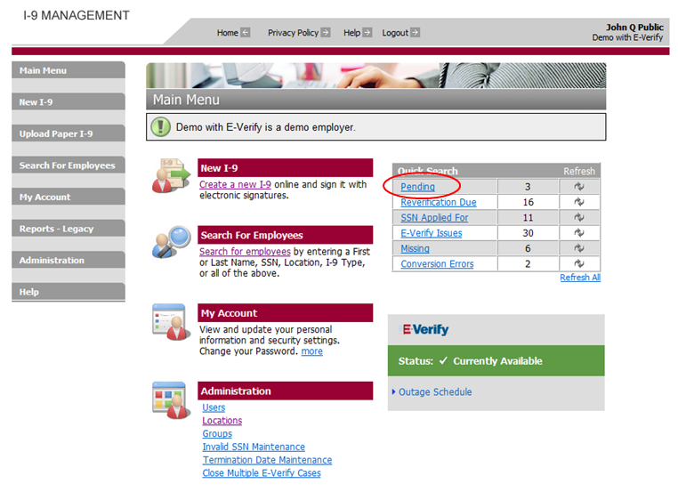

### Screen Shot: Main Menu – Pending Form I-9 Search Results

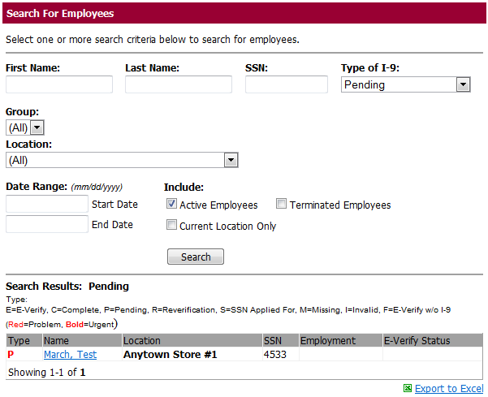

## Employee Search

* **Availability** – All clients have the ability to search for Completed Forms I-9.
* **Search Description** – The search for completed Forms I-9 provides a list of all completed Forms I-9 meeting the criteria specified by the user. The user can use these search results to view the status of a specific employee, view all completed Forms I-9 for one location, or view all completed Forms I-9 for all locations.
* **Search Result Format** – The search results are initially displayed in webManager. If the user wants to view the data in more detail, select the **Export to Excel** link on lower right of the screen. Additional data is available in the Employer Search Exports report.
* **Search Parameters** – The user must specify the search parameters on the employee search screen. To make the information easier to find and reduce search time, narrow your search as much as possible to include only the desired data.
  + First Name – Leave blank unless you are looking for a specific employee.
  + Last Name – Leave blank unless you are looking for a specific employee.
  + SSN – Leave blank unless you are looking for a specific employee.
  + Type of I-9 – Select ‘Complete’.
  + Group – Select all or specific group.
  + Location – Select all or specific location.
  + Employment Date (Start Date / End Date) – User can specify a date or date range for the search (not required).
* **Search Result Contents** – The search results contain limited information.
  + Type (Form I-9 Status)
  + Name – Employee first and last name
  + Location
  + SSN (only displays last 4 digits)
  + Employment – Employment date / hire date.
  + E-Verify status – Current E-Verify status (only for clients using E-Verify)

To view additional data for the completed Forms I-9, click the **Export to Excel** link on the lower right of the screen or request the Employer Search Export report via the **Reports** link.

## Employee Search Access

**Step 1:** Click **Search for Employees** on the webManager **Main Menu** screen. There are two separate links on the **Main Menu** screen for search for employees. The search screen can be accessed through either.

**Step 2:** Enter the desired search criteria, and click **Search**.

**Step 3:** The search results will be displayed, 25 rows per page. To export the data, click the **Export to Excel** link on the lower right of the screen or request the **Employer Search Export** report via the **Reports** link.

### Screen Shot: Main Menu Screen

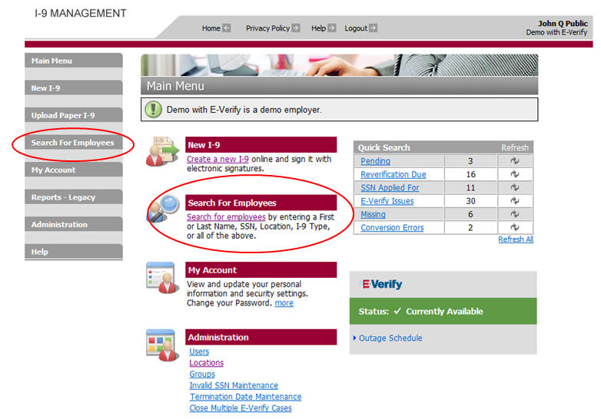

### Screen Shot: Employee Search Screen

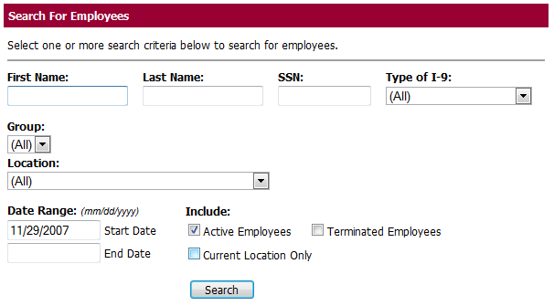

### Screen Shot: Search Results Screen

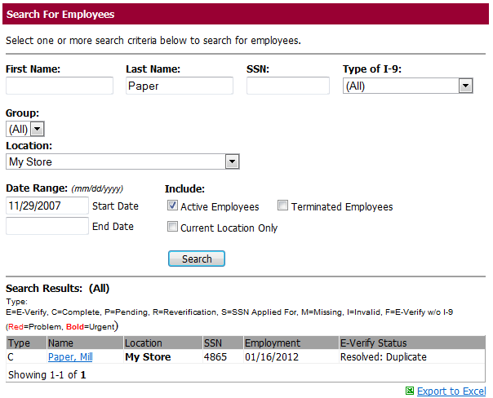

## Export to Excel

The Export to Excel option is available based on the user’s role. The Excel export contains more data than the search results displayed after a search is performed.

Below is a table showing the data elements included in the Excel export by type of Form I-9.

|  |  |  |  |  |  |  |
| --- | --- | --- | --- | --- | --- | --- |
|  | **Pending** | **Complete** | **E-Verify** | **Reverify** | **SSN Applied For** | **Missing** |
| **Type** | X | X | X | X | X | X |
| **Location Code** | X | X | X | X | X | X |
| **Location Name** | X | X | X | X | X | X |
| **SSN (last 4 digits)** | X | X | X | X |  | X |
| **Employee First Name** | X | X | X | X | X | X |
| **Employee Middle Initial** | X | X | X | X | X | X |
| **Employee Last Name** | X | X | X | X | X | X |
| **Employee Maiden Name** | X | X | X | X | X | X |
| **Employee Date of Birth** | X | X | X | X | X | X |
| **Entry Date/Time (Form I-9 Section 2 Signature or  Pending Form I-9 Entry Date)** | X | X | X | X | X | X |
| **Employment Date** | X | X | X | X | X | X |
| **Immigration Status** | X | X | X | X | X |  |
| **Work Expiry Date** | X | X | X | X | X |  |
| **Preparer Name** | X | X | X | X | X |  |
| **Section 2 Signature Name** |  | X | X | X | X |  |
| **E-Verify Status \*** |  | X | X | X |  |  |
| **SSA Referral Date \*** |  | X | X | X |  |  |
| **DHS Referral Date \*** |  | X | X | X |  |  |
| **E-Verify Case Number \*** |  | X | X | X |  |  |

* Columns only appear for E-Verify clients.

## Type of Form I-9

The search field labeled **Type of I-9** allows the user to narrow the search to return results that include only Forms I-9 with the status selected. While the statuses of Pending, E-Verify Issues, Reverification Due, and Missing include only Forms I-9 with those specific statuses, the Completed and ALL categories actually include Forms I-9 in multiple status categories. This is because it is possible for a Form I-9 to satisfy more than one status. For example, a Reverification Due Form I-9 and an E-Verify Issues Form I-9 are both Completed Forms I-9. Therefore, they will show in all three categories. Below is a description of the Completed and ALL category contents.

* Completed – Includes Forms I-9 with both Section 1 and Section 2 completed and signed. This includes Forms I-9 with a status of E-Verify Issues and Reverification Due because these Forms I-9 are also completed. Therefore, E-Verify Issues and Reverification Due Forms I-9 will appear in the results when Completed is selected as the Type of I-9.
* All – The results returned for the ALL category are dependent on the other search criteria selected.
* If you specify a First Name, Last Name, or SSN in your search criteria and you select ALL as the Type of I-9, the results returned will include any Forms I-9 that satisfy the search criteria (e.g., name and SSN) entered. The search results will include all Pending, Missing, Reverification Due, Completed, and E-Verify Issues Forms I-9 that satisfy the search criteria. The purpose for this search is to find an employee’s Form I-9 when you know who the employee is but you do not know the status of the employee’s Form I-9.
  + If you do NOT specify a First Name, Last Name, or SSN in your search criteria and you select ALL as the Type of I-9, the search results will NOT include Pending Forms I-9. The search results will include all other possible Forms I-9 types except for Pending Forms I-9.