Business Process Guide

Recruiting Solutions:

Create a Job Opening

06/23/2015

Table of Contents
Double Click Here to Change Text
Table of Contents i
Process Overview 1
Where the Data for This Process Comes From 1
Where the Data from This Process Goes 1
Related Information 2
Prerequisites and Assumptions 2
Helpful Hints 3
1.0 Create a Job Opening 5
Decision Chart – Standard or Continuous? 5
Job Posting Scenarios 6
Process Steps 7
2.0: Cloning Job Openings 20
Expected Outcomes 23
Appendix A: Multiple Position Numbers on Job Openings 24
Appendix B: Job Posting Description Types 26
Appendix C: Job Posting Guidelines 27
Appendix D: Academic Series Jobs 28
Job Opening Details 28
Tenured and Tenure Track Openings 29
Open Rank Job Codes 30
Appendix E: Frequently Asked Questions 33

Process Overview
Job openings provide the foundation for Recruiting. These are what we use to attract candidates, manage applicant activities, and ultimately hire new employees. The University of Minnesota requires that a job opening be posted to the Careers website for most hiring activity. This is defined by UM Policy, Labor contracts, and our Civil Service rules.

Where the Data for This Process Comes From
The data for this process comes from Position Management and from departmental job descriptions.

Where the Data from This Process Goes
The data from the job opening posts to the Careers site and is used to attract applicants to apply to the University for internal and external applicants.

Related Information

Prerequisites and Assumptions
Before you can successfully perform the Create a Job Opening process, it is either required or assumed that each of the following conditions has been met:
Prerequisites and Assumptions
Prerequisite/Assumption | Detail
Accurate Position Data | Recruiting relies heavily on accurate position data. Compensation Review and position review/updates occur prior to creating the job opening.
Must have a Position Number | Position number populates relevant job data for the position
Must have a job description available | Identifies job duties and position qualifications needed to perform job for the posting content.
Recruitment Approvals | Approvals for the job opening and posting content will be approved by designated employees with the “Central Recruiter” security role.
Service Level Agreement | Agreement between central Recruiters and Unit HR

Helpful Hints
- The Recruiting Home page can be personalized. Click on Pagelet Settings as shown below to modify what is presented on the page.
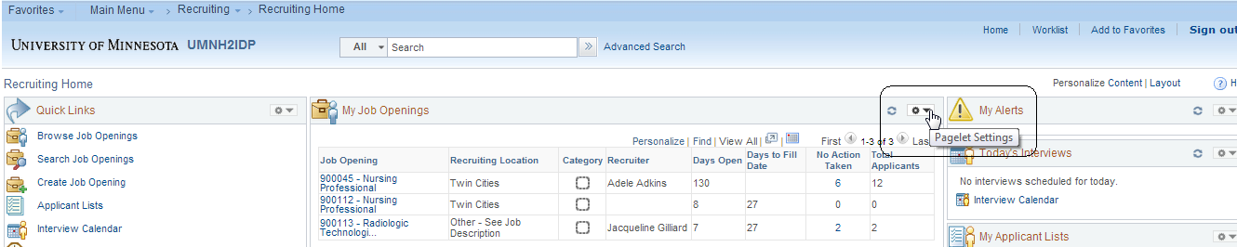
The Personalize My Job Openings page displays. Select the options and click save. The Recruiting Home page displays with the filter options selected. You can change these settings at any time.
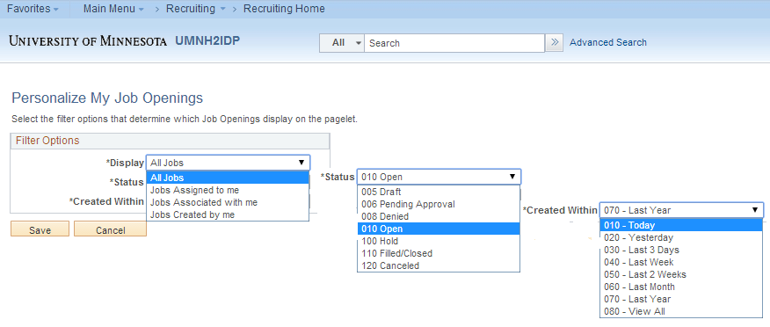
- Click on any heading to sort. Click on Refresh My Job Openings to update any new activity on the page.
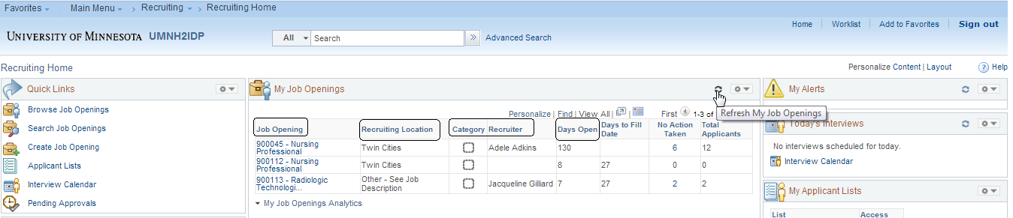

- If, at any time, you are lost in navigation click on Recruiting Home.
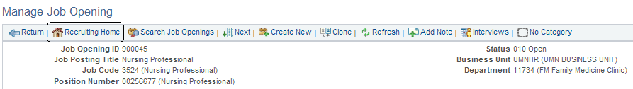

Create a Job Opening
All job openings are created from approved positions. New or modified positions require review prior to creating the job opening. If you have any questions on this, discuss with your position manager.

You can create two different types of job openings. Both types follow the same process in the system, but they are used for different purposes.

Standard Job Openings are created when there are a limited number of vacancies, the position is appropriately classified, and the anticipated hire date is known.
Continuous Job Openings are created using a position(s) when there is an ongoing need to hire with no anticipated hire date. These are considered “blanket” job openings.

Decision Chart – Standard or Continuous?
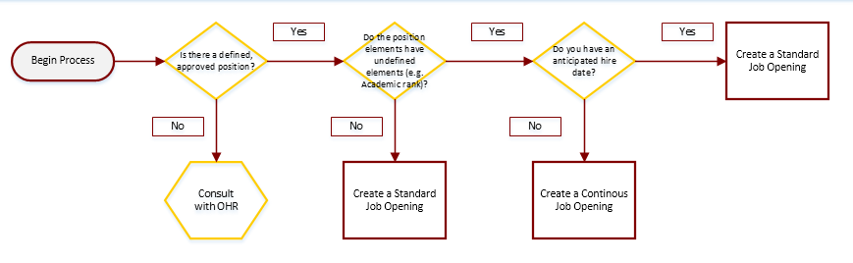

Scenario | Comments | Standard | Continuous
I have defined approved position(s) and may hire one or more applicants into the position(s) with a projected fill date. | This could be any approved position
I have a job opening with approved positions. There is no anticipated hire date, as hiring is done on an as-needed basis. | Because there is no anticipated hire date, this should be a continuous opening.
I have high volume recruiting needs for the same type of work (ex: Lab Attendant, Food Service Worker, Student Building and Grounds). I have approved positions for the opening. There is an anticipated hire date. | Hire will be made against position(s) defined in job opening.
I am hiring a tenure or tenure-track Faculty with an approved position. Rank is unknown until time of hire. | These are authorized, approved searches, so though you may not know the rank, a standard job opening is appropriate.
I would like to have a pool of qualified candidates to draw from for future vacancies. | This is considered a candidate pipeline and can be used to move applicants to standard or job openings when vacancies become available.

Job Posting Scenarios

Process Steps
Step 1: Navigate to “Create Job Opening”
Navigate one of two ways:
1. Main Menu > Recruiting > Create Job Opening or
2. Main Menu > Recruiting > Recruiting Home and use the Quick Links on the left side of the page
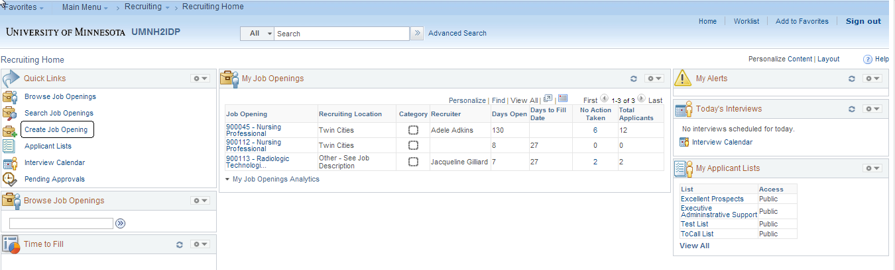

Step 2: Create Job Opening
Select what type of job opening (Standard Requisition or Continuous Job Opening) you are creating and then enter the Position Number.
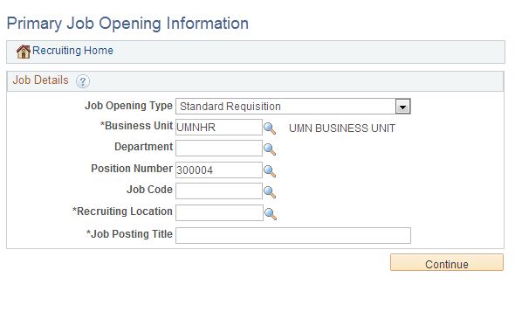

Once you have selected a job opening type, and clicked Continue, you may not change the opening type. If you need to change from a Standard Requisition to a Continuing Job Opening, you will need to create a new job opening.

Position Numbers must always be used when creating job openings.

Once you enter a position number and tab out of the field, the rest of the information will default and display:
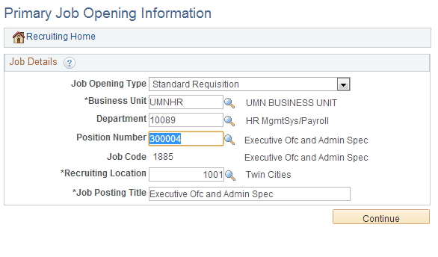
Click “Continue” to create the job opening.
The Job Opening Details tab displays.
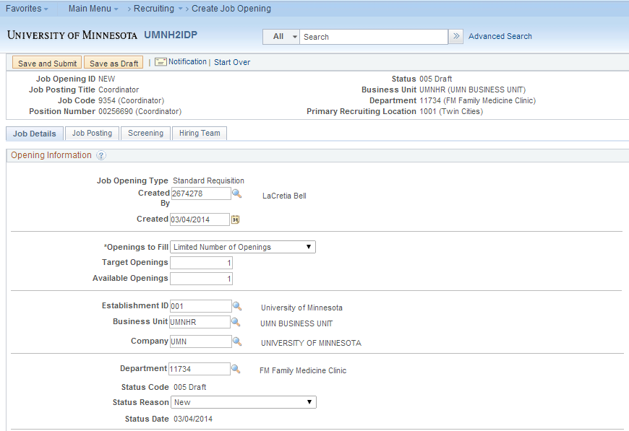

Step 3: Job Details Tab
A Job Opening is comprised of 4 tabs: Job Details, Job Posting, Screening (Recruiters only), Hiring Team. Each page is to be completed, except where noted.
The Job Details tab contains the data elements of the job opening. Most of this information defaults from the position used in the job opening.

Job Opening Type: Selected at creation.
Created by: Creator’s user ID and name defaults
Created: Date created defaults to the current date.

Openings to Fill: Leave at Limited Number of Openings. If you have a multiple headcount in the position, do not exceed the max headcount on the position.
Target Openings: Number of openings for the job. You may enter a number or “unlimited”, if the number is unknown.
Available Openings: Number of openings left to fill.
The system automatically decrements against this number if you hire against a job opening with multiple Target openings.
Example: You post a job opening with 5 initial target openings. When you hire one person, the Available Openings will be reduced to 4.
The following fields default from Position. Do not change these values.

Department: Defaults from the department on position data
Status Code: Defaults to Draft
Status Reason: Defaults to New Change if the opening is a replacement.
Status Date: Defaults to current date
The following dates will be used to track Recruiting Metrics and support the Service Level Agreement with central Recruiting staff.

Desired Start Date: Enter the date that you would like for an applicant(s) to start.
Projected Fill Date: Enter the date you anticipate that the opening will be filled.
Date Authorized: No Entry. The field auto-populates with system date upon approval.

Referral Program ID & Recruitment Contact - leave blank. The University of Minnesota does not use these fields in this process.
Locations
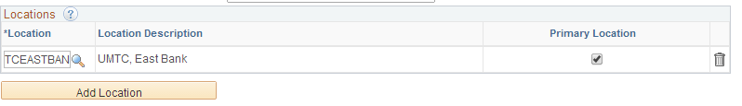
The Location defaults from the Position. Do not enter or change this information.

Recruiting Locations
Recruiting Locations default from the Location – you may enter or change, depending on your needs. Recruiting Locations are used on the jobs site for applicants to search.
The following locations are set up in Recruiting:
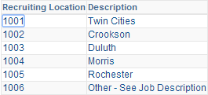

Positions
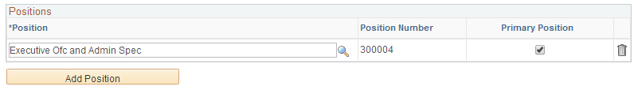
You have the ability to hire against multiple positions on one job opening. If you need to add more positions to the job opening, you do so by clicking on “Add Position” and adding the position to the opening. Location and Recruiting locations default when additional positions are entered.
There are rules associated with when you should use multiple positions for one job opening. Please see the appendix for more information.
Employees Being Replaced
If this is a replacement job opening, enter the ID of the employee being replaced. While position management does track incumbent history, there may be times when a job opening is created from a new position number, but is an actual replacement.

Additional Job Specifications
Most of these fields do not display to applicants, but the data is used in the Advanced Job Search.
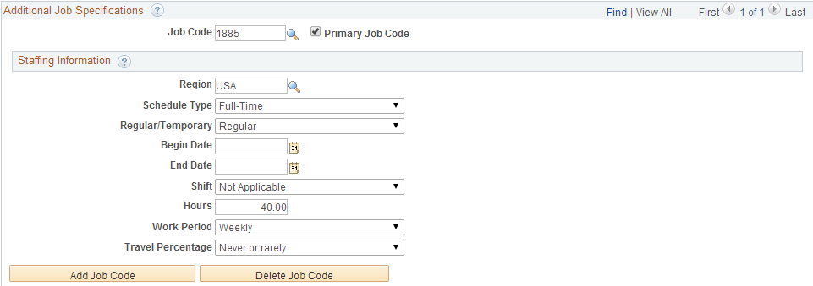
This date comes from the Position Number and, unless noted, should not be changed on the opening.
Schedule Type: Used to denote full or part-time employment.
Regular/Temporary: This field flows from the HR definition of Reg/Temp. In core HR (Position and Job Data), if the position is greater than 3 months, it is considered Regular.
Recruiting has a different need for Regular or Temporary, and you may update this field if the job opening is a Temporary Posted or Temporary Non Posted vacancy.
This field will be displayed to applicants on the jobs site and should reflect the status of the opening from an applicant’s perspective. For example, if a job opening is for a six month period of time, an applicant would consider that Temporary. This also ensures that we can accurately track for Temporary vacancies, per our labor agreements.

Begin and End Dates: Leave blank unless the opening is a Temporary posted or Temporary non-posted position; in those cases, you must enter a tentative begin and end date. These fields are used to identify that the job opening is a Seniority type of TNP or TP.
Shift: Enter shift, if applicable
Hours: Populated from position. Do not change.
Work Period: Defaults from position. Do not change.
Travel Percentage: N/A unless the job requires travel

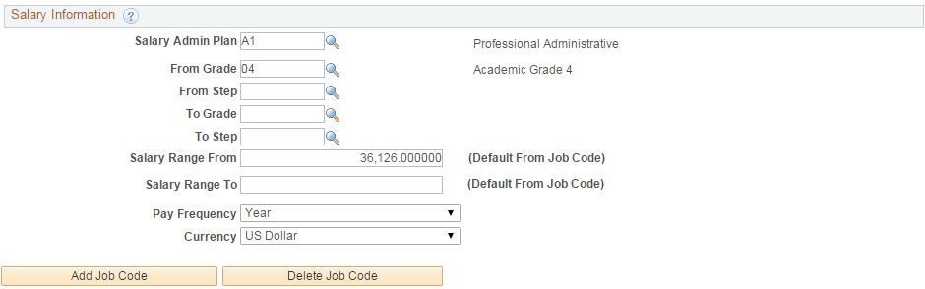
The salary information does not display to applicants, but a Salary Range From and Salary Range To must be entered. Many job codes do not have from/to ranges, so you should put in your most likely salary range for the opening. The range is used in the applicant’s advanced search functionality.

Step 4: Job Posting
Click on the Job Posting tab at the top of the Job Opening page and the Job Posting page displays.
Job Postings contain text that applicants will see on the jobs site. It is helpful to have a Position Description available as you can copy and paste the content into the job posting
To add posting content click on “Add Job Posting”.
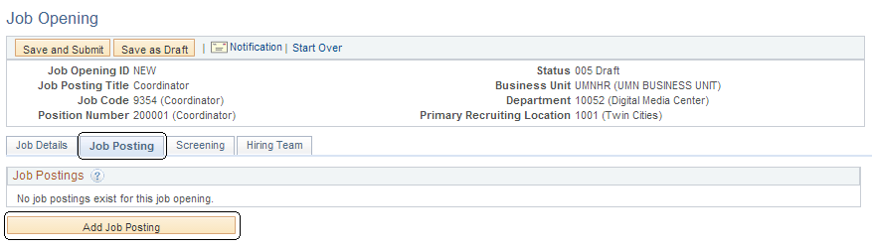

The posting section displays. You may add multiple sections (Description Types) to a job posting.
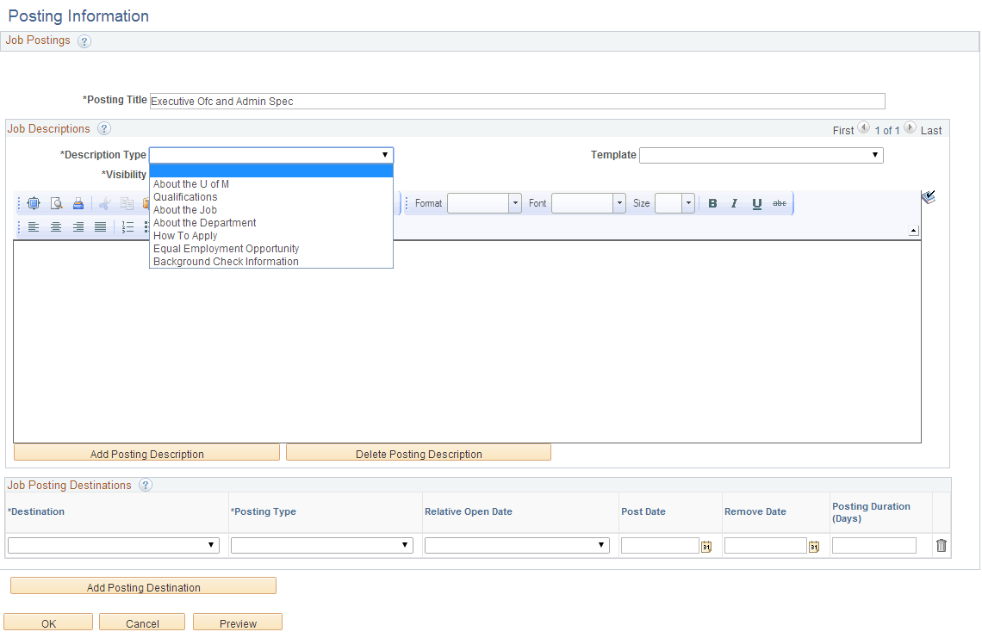
Description Type: Select from the list of available types. See appendix Job Posting Description Types for more information.
Template: Select the Template from the list of available types for the Description Type. Prepopulated templates will default the content into the posting for some of the description types.
Visibility: Select the visibility type from the list of options. Posting sections (Description Types) can have different view capabilities for internal and external applicants with different posting dates. Options are:
- External Only – the section is visible to External Applicants only.
- Internal Only – the section is visible to Internal Applicants only.
- Internal and External – the section is visible to both Internal and External applicants.
In order to be compliant with regulations, postings should use the same language for internal and external audiences. Due to that, the best practice is to choose “Internal and External” if the posting is to display to both audiences.
To post to the jobs site, click on “Add Posting Destination”
Destination: Always select “I”
Posting Type: Internal or External Posting. These options control the types of applicants who can view the posting.
Relative Open Date: Select from the Options
Post Date: Defaults based on the Relative Open Date; you may also select a post date instead of a relative open date.
Remove Date: Optional. The job opening will close and un-post automatically when the Person is hired into the job. If you decide to remove the posting early, the Remove Date can be entered later.
Posting Duration: Automatically calculates from the Remove Date.
Note: Please see appendix Job Posting Guidelines for minimum posting time period.
When finished click on the Job Posting Tab. The posting page displays. Click on the Posting title to view or edit the Job Posting Details.
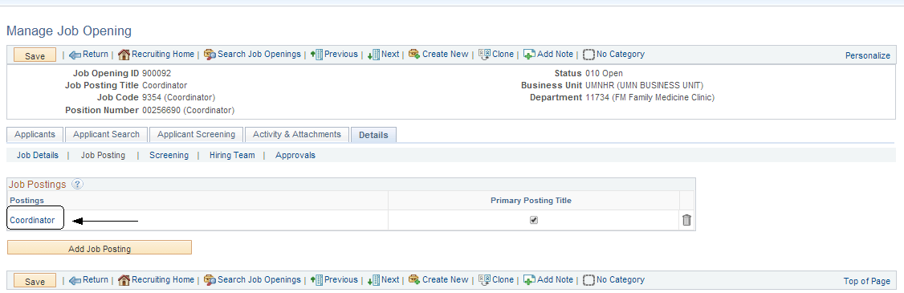

Step 5: Hiring Team
Click on the Hiring Team tab.
The Hiring Team page displays. Due to the restrictive nature of Recruiting security, the users listed on the hiring team are the only users who will be able to access the job opening. It is required that anyone who needs to access the job opening and applicants be listed on this page.
Enter the correct recruiters, hiring manager and Search Committee members (if applicable). Search Committee members may be added as members of the Interview Team or Screening Team.
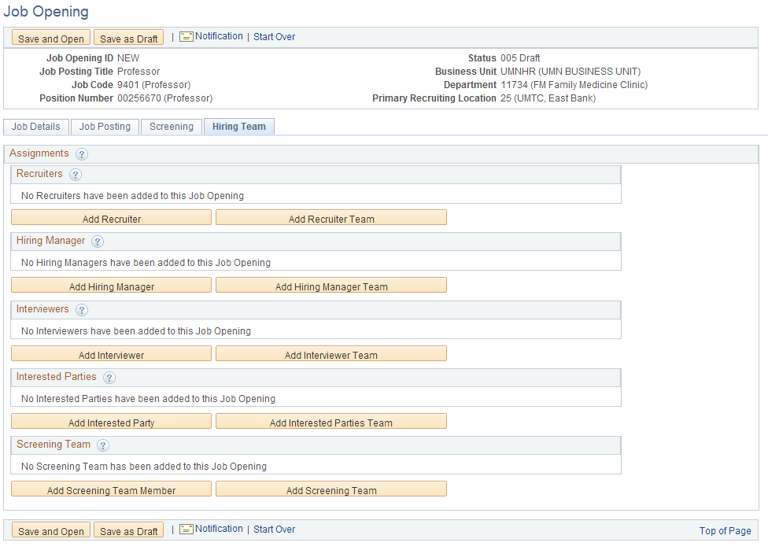
To add a recruiter, click on “Add Recruiter”. You will be able to look up recruiters, or enter in the Recruiter’s name.
The central recruiter is always the primary on the job opening. The secondary recruiter is a person with the recruiter role in a college or unit.
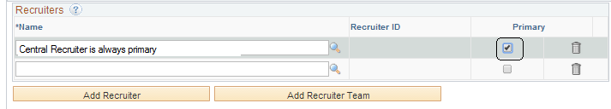
To add a Hiring Manager, click on “Add Hiring Manager”.
The Hiring Manager is the person who is responsible for hiring on this job opening; this may be a direct supervisor or departmental administrator with the Hiring Manager role. If more than one hiring manager is entered, indicate which person is the primary.
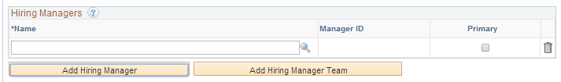
Click on Add Interview Team Member or Add Screening team Member (Used for Search Committee members only)
Add if a search committee member will be part of the applicant review. The users listed in this grid have security access to the job opening and applicants.
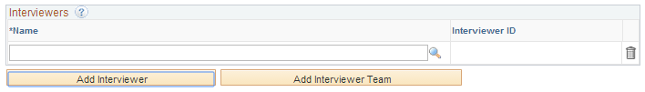
Once all pages are complete click on one of the options below.

Click “Save and Submit” to route your job opening for approval. If you are not finished, you can click “Save as Draft” to come back to the opening another time.

Upon submitting the job opening, the page for Job Approvals displays and the status is now Pending Approval.
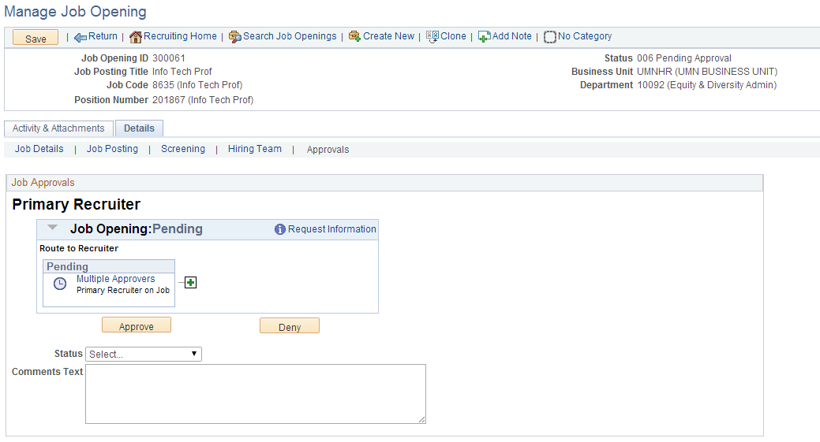

2.0: Cloning Job Openings
The Clone Job Opening functionality allows you to easily re-create an old job opening. If you have previously filled an opening, and the vacancy is now available again, you can use the Clone function instead of starting over. Cloned job openings follow the same approval process as other new job openings.

Cloning can be accessed from within a job opening. You may need to search for your old job opening using “Search Job Openings”
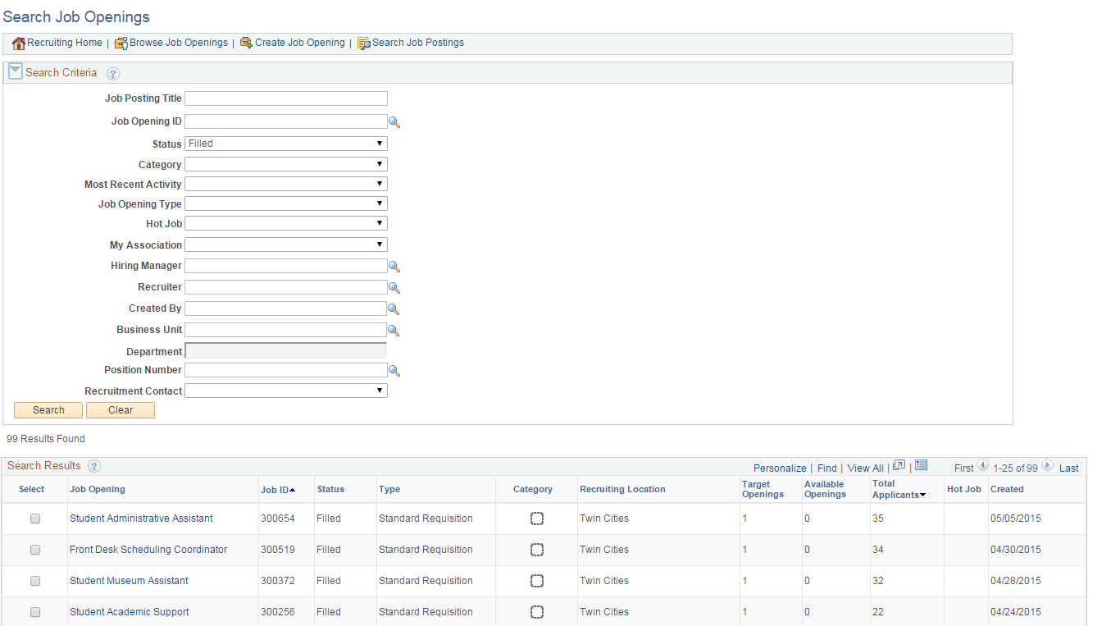

You can click on any link to view the opening. The Clone option displays at the top of the page. Click on Clone
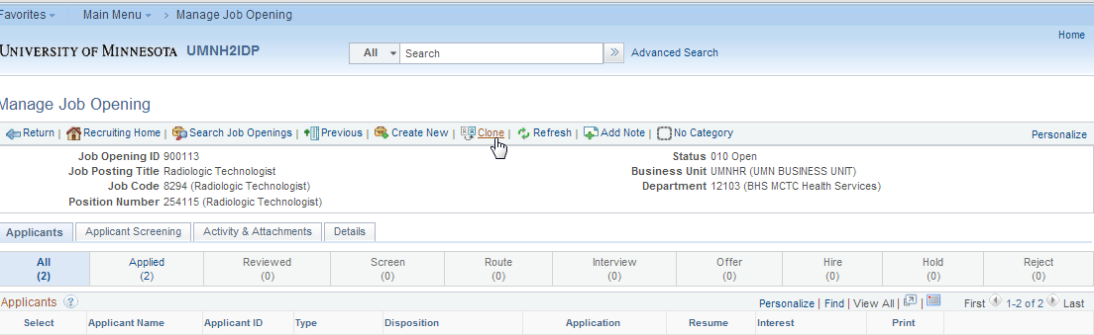

The Clone Job Opening page displays. Click on the Clone button
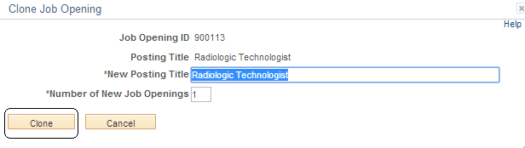

After clicking on Clone, you will see a message that your job opening was successfully cloned. Cloned job openings default to Draft status. In order to make any changes, add new posting dates, and submit for approval, you will need to click on the Job Opening ID link.
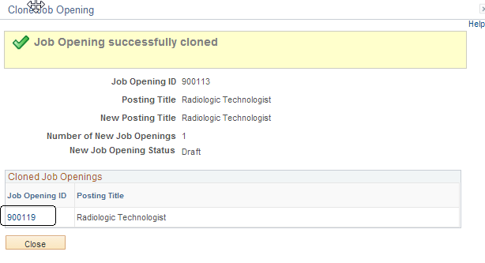
The Job Opening displays. You may modify the Job Posting and view and update the Hiring Team page as needed. Click on the Job Posting Tab to modify dates and the Hiring Team page to update Recruiters or Hiring Managers, if necessary.
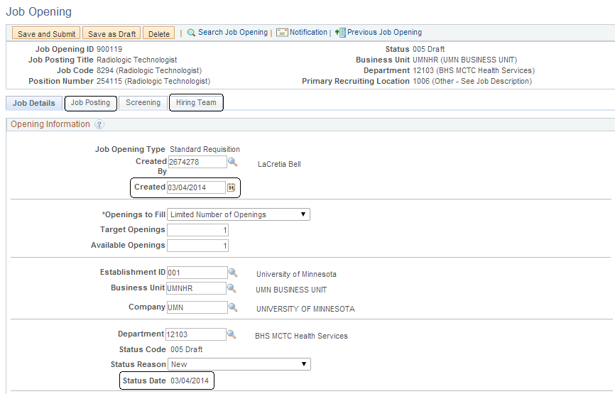

Once you have completed this, click Save and Submit to route the opening through the approval process.

Expected Outcomes
Using this Business Process Guide, you should be able to obtain the following results:
- You are able to create a Job Opening
- You are able to clone a Job Opening

Appendix A: Multiple Position Numbers on Job Openings
Use this chart to help decide whether it is appropriate to use multiple position numbers on your job opening.

As a general rule, if you are hiring into one level, where all attributes are the same, then you may use one position number. You will need to use multiple positions if you are hiring into multiple vacancies that have differences such as standard hours, reports to, location.

Question | Yes | No | Long Answer
I am hiring two Civil Service employees. Can I use one job opening with two position numbers to recruit my applicants? |  |  | Civil Service job openings are approved for one job code. As long as the positions you use have the same job code and other similar attributes, you may use one job opening with both positions associated to the job.  You cannot do this if the job codes are different.
I would like to recruit for a Building and Grounds worker and Senior Building and Grounds worker on the same job opening. Can I do this? |  |  | Teamsters’ job openings must be posted with one job code. While these jobs are in the same job family, our bargaining unit agreement prohibits this.
I am hiring student workers for a variety of jobs. Can I collect all my student applicants on one job opening, even though the positions that I hire into are very different? |  |  | Student employment is more flexible than some of our other groups. If you have a need to mass hire student employees into different kinds of work from one job opening, you could do this as long as you associate the appropriate position numbers with the job opening.
I am hiring an AFSCME Clerical employee. Can I post the job without knowing which position and job code I will be hiring against? |  |  | All of our Civil Service and Labor represented job openings must have a known job code prior to posting. You will be required to use an approved position, which has a job code attached to it, to create your job opening. AFSCME contract stipulates that one job code is associated with one job opening. You may, however, use different position numbers if they have the same job code!
I have a need to hire for tenure-track faculty. I will not know the faculty rank until I am ready to make the offer. Is this okay? |  |  | Faculty, and some of our other Academic hires (such as Librarians), are hired into the rank based on the experience they bring. This would be a standard job opening and you could decide rank at time of offer. You can create the job opening with multiple position numbers at different ranks, so that the right one is available for you when you are ready to make the offer.

Appendix B: Job Posting Description Types
Job Posting descriptions are the fields that will display to applicants on the jobs site. These fields help to market the job posting and can be used to market your department.

About the U of M
This is a marketing statement about the University of Minnesota. There are templates available for all of the campuses.

Qualifications
The qualifications should outline the minimum and preferred qualifications necessary to perform the duties of the job opening. If you are unsure of this, you may reference the job classification website to pull the generic job description for the job code (https://www.myu.umn.edu/jobclass). This is required for all job openings.

About the Job
The about the job type should outline the duties and responsibilities that the hired applicant will perform. This section may also contain salary, appointment, and other pertinent information.

About the Department
You may enter a marketing statement about your department or college/unit in this section.

How to Apply
There are templates available for this description type, which can be used as a base to provide information to an applicant. You may want to enter any additional information required for your opening in these

Diversity and Inclusion
The template provided is the University approved diversity and inclusion language for job openings. This is required for all job openings.

Background Check Information
The template provided is the University approved background check language for job openings. This is required for all job openings.

Appendix C: Job Posting Guidelines

Employee Group | Posting Time Period | Best Practice
Minnesota Public Employees Association | 5 calendar days required | After 5 days, review internal and priority applicants. If additional applicants are needed, keep job posted and review applicants regularly. When approximately 3.5 well qualified applicants per opening have been identified, evaluate applicant pool in conjunction with unit HR and/or EOAA Liaison. If applicant pool is sufficient, remove posting and proceed to interview step.
Teamsters  AFSCME Health Care  AFSCME Clerical & Office  AFSCME Technical  Civil Service | 7 calendar days required | After 7 days, review internal and priority applicants. If additional applicants are needed, keep job posted and review applicants regularly. When approximately 3-5 well qualified applicants per opening have been identified, evaluate applicant pool in conjunction with unit HR and/or EOAA Liaison. If applicant pool is sufficient, remove posting and proceed to interview step.
P&A | Until 3-5 well qualified applicants are identified | Execute recruitment plan to include posting, advertising, and active outreach. Review applicants regularly. When approximately 3-5 well qualified applicants per opening have been identified, evaluate applicant pool in conjunction with unit HR and/or EOAA Liaison. If applicant pool is sufficient, remove posting and proceed to interview step. If, after 2-3 weeks, more applicants are needed, augment recruitment plan with additional advertising and/or outreach efforts. If, after 3-5 weeks, additional applicants are still needed, determine alternative means for filling positions or consider redesigning the position.
Faculty | Until filled
Senior Leader | Until filled
Blanket/Continuous | No Longer than 1 calendar year

Appendix D: Academic Series Jobs
Many types of Academic jobs have an Open Rank system. This means that you may post the job opening and can make an offer and hire into the appropriate level based on the desired candidate’s qualifications and experience.

When you post for these types of job openings, you must make sure that the language on your posting states that the vacancy is for various levels. You must also make sure that you have position or job code data on the job opening that reflects the multiple levels.

Example language:
This is a full time, 12 month, continuous-track, academic professional position with probationary appointment at Assistant or Associate Librarian level.

Job Opening Details
The best practice is to create your job opening with a position number for the level that you are most likely going to use for the hire. You can then add positions for the other levels by using the Add Position function on the Job Details page:
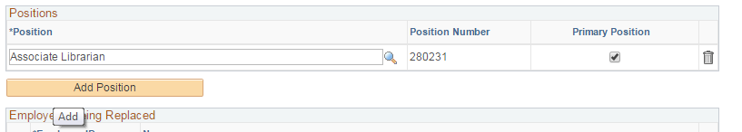

You may need to work with your position manager to ensure that there are positions for all possible levels.

If you are ultimately only going to make one hire into one position at an unknown level, then the best practice is to use the position you have created, and add multiple job codes to the opening. Your central Recruiter can help you understand when it is appropriate to add multiple positions compared to multiple job codes. It is important for our EOAA reporting that we advertise our positions with the proper language and have data that reflects the possible levels of the position.

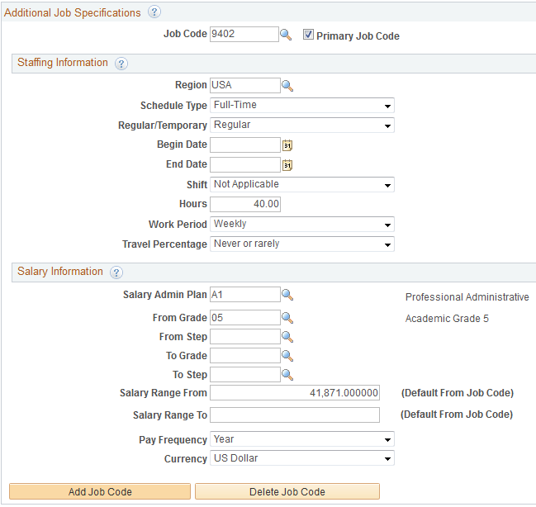

Tenured and Tenure Track Openings
You will need to create two separate job openings for Tenured and Tenure Track vacancies. The pool received for Tenured compared to Tenure-Track may be different, so we need to advertise the openings as two separate opportunities, even though you may only hire into one of your openings.

Open Rank Job Codes
Job Code and Title Indicated on Job Opening
9401 Professor | Regular Faculty Tenured
9402 Associate Professor
9401 Professor | Regular Faculty Tenure-Track
9402 Associate Professor
9403 Assistant Professor
9404 Instructor
9401 Professor | Term Faculty
9402 Associate Professor
9403 Assistant Professor
9404 Instructor
9771 Senior Teaching Specialist | Instructional (Non-Faculty) Teaching
9754 Teaching Specialist
9770 Senior Lecturer
9753 Lecturer
9702 Research Associate | Research
9701 Senior Research Associate
9703 Research Fellow
9704 Senior Research Fellow
9621 Extension Educator & Professor | Extension Educator
9622 Extension Educator & Associate Professor
9623 Extension Educator & Assistant Professor
9624 Extension Educator & Instructor
9625 Extension Educator
9352 Associate To | Associate/Assistant To
9353 Assistant To
9327 Senior Vice President | Vice President
9302 Vice President
9303 Associate Vice President
9304 Assistant Vice President
9305 Chancellor | Chancellor
9306 Associate Chancellor
9307 Assistant Chancellor
9308 Vice Chancellor | Vice Chancellor
9309 Associate Vice Chancellor
9310 Assistant Vice Chancellor
9311 Dean | Dean
9312 Associate Dean
9313 Assistant Dean
9322 Associate Vice Provost | Vice Provost
9323 Assistant Vice Provost
9328 Vice Provost
9324 Assistant Provost | Provost
9325 Associate Provost
9326 Provost
9330 Director (University-Wide) | Director University-Wide
9331 Associate Director Univ Wide
9333 Assistant Director Univ Wide
9334 Director Campus/College Level | Director Campus/College
9335 Associate Director Campus/College
9336 Assistant Director Campus/College
9337 Departmental Director | Departmental Director
9338 Associate Department Director
9339 Assistant Department Director
9340 Program Director | Program Director
9341 Associate Program Director
9342 Assistant Program Director
9370 Senior Analyst | Analyst
9371 Analyst
9372 Associate Analyst
9704 Senior Counselor | Counselor
9705 Counselor
9706 Assistant Counselor
9711 Associate Counselor
9707 Senior Academic Advisor | Academic Advisor
9708 Associate Academic Advisor
9709 Assistant Academic Advisor
9713 Librarian | Librarian
9714 Associate Librarian
9715 Assistant Librarian
9716 Senior Development Officer | Development Officer
9717 Development Officer
9718 Associate Development Officer
9720 Senior Physician | Physician
9721 Physician
9723 Senior Psychologist | Psychologist
9724 Psychologist
9712 Associate Psychologist
9725 Senior Psychiatric Social Worker | Psychiatric Social Worker
9726 Psychiatric Social Worker
9727 Senior Public Health Specialist | Public Health Specialist
9728 Public Health Specialist
9729 Continuing Education Specialist | Continuing Education Specialist Series
9730 Associate Continuing Education Specialist
9731 Assistant Continuing Education Specialist
9732 Clinical Specialist | Clinical Specialist
9733 Associate Clinical Specialist
9734 Assistant Clinical Specialist
9735 Senior Attorney | Attorney
9736 Attorney
9739 Curator | Curator
9740 Associate Curator
9741 Assistant Curator
9745 Education Specialist | Education Specialist
9746 Associate Education Specialist
9747 Assistant Education Specialist
9748 Associate General Counsel | General Counsel
9749 Assistant General Counsel
9759 Business Development Specialist | Business Development Specialist
9760 Associate Business Development Specialist
9761 Assistant Business Development Specialist
9762 Senior Cartographer | Cartographer
9763 Cartographer
9764 Counselor/Advocate | Counselor/Advocate
9765 Associate Counselor/Advocate
9766 Assistant Counselor/Advocate
9767 Senior Acquisitions Editor | Acquisitions Editor Series
9768 Acquisitions Editor
9791 Head Coach | Coach
9792 Coach
9793 Assistant Coach
9794 Athletic Trainer | Athletic Trainer
9795 Assistant Athletic Trainer
9548 Veterinary Medical Resident | Veterinary Medical
9549 Veterinary Resident – Grad Prgrm

Appendix E: Frequently Asked Questions
1. What exactly does "hiring manager" access give a person? Is it access to only one unit or DeptId? If so, how would they get access to multiple units? Can there be more than one hiring manager on a requisition?

Hiring Manager access will give a user access to their own job openings and applicant pools. They cannot look at all applicants in the system (the way a Unit Recruiter would), and they have very limited options in how to act on their applicant pools. The access is not by unit or deptid, but rather by job opening itself. All non-central users must be on a job opening in order to view and access it.

There can be as many hiring managers as you need on a job opening.
2. Previously, we have had to post tenure-track and tenured faculty postings separately in order to maintain demographic tracking for EOAA purposes. Is this still the case? Or are we allowed to post them on the same job opening in Recruiting Solutions? The "Adding Multiple Position Numbers to Job Openings" resource document isn't that clear on this.

Yes, we should still post for both tenured and tenure track vacancies separately for EOAA purposes. This is the cleanest way to track pools for tenure/tenure-track. You may use the same position numbers, as you do in today's world, to create the openings, but they should be two distinct job openings.
3. Will series job codes still exist? With job family studies, the series will probably look different if they do still exist, right? If so, is there a new listing or job aid for the new series codes?

No, series codes will no longer exist. We are now creating job openings from valid, approved positions. Positions will never be created with a "dummy" job code, because you cannot hire into these job codes. This is why you have the ability to add multiple positions and job codes to a job opening.
4. For a job opening with multiple job codes, which should we list as the primary? Will the primary job code be the job code that populates fields.
Everything will come from position, not job code, as it does today. The primary position will populate the fields. You will list multiple positions on the job opening and the primary would be the position at the level that you feel you will most likely hire into.

5. What is the difference between the "Add Position" on the Positions section and the "Add Job Code" on the Staffing Information section. Both are the on the "Job Opening" page. Do both need to be entered for a job posting with multiple job codes/position numbers?

There is a subtle difference between the two in terms of how you would use these functions.

Using multiple positions works best when you are hiring into those positions. When you post for your blanket teaching specialist/lecturers, for example, you probably hire into more than one position. You could put all of the positions on the job opening, and they would all be available for you to hire the applicants into. Adding multiple positions will also add the corresponding job codes, so all pertinent information will be captured on the opening.

If you are hiring for a faculty (either tenured or tenure-track) vacancy that is not for multiple openings, then it would make more sense to have one position (created and approved at the level that you are most likely to hire into), and add the other job codes that could be used depending on the pool. You will continue to advertise the postings the way you do today (stating that it could be x, y, or z level, etc.), and the job codes on the opening help tie the information together. If you do hire into a different level, then you will need to go back and update the position to the appropriate job code prior to hiring the applicant.
6. Does the "Available Openings" automatically update as a hire is made on the job opening? So, if we have a Target opening of 3 hires and we mark a candidate as Hired and sent to Manage Hires, will the Available Openings change to 2 as soon as we move the hire over?
Yes. When an applicant is hired into job data, their disposition changes from Ready to Hire to Hired, and the available openings decrements by one. If you are at your last available opening, then the job opening will also change status to filled.

