Recruiting Solutions:

Search Committee User Guide

08/17/2015

Table of Contents
Double Click Here to Change Text
Table of Contents i
Search Committee Information 1
Relationship between the Responsible Administrator and the Search Committee 1
Who Can Know Information About Applicants? 1
Affirmative Action Obligations in a Search 2
Evaluation of Applicant Pool 3
System How-To 4
Navigation 4
Understanding the Recruiting Home 5
Manage Job Opening Page 8
Expected Outcomes 13

Search Committee Information
A search committee is a group of individuals formed for purposes of recruiting, screening, interviewing, and recommending candidates for a vacancy. An interview panel is a group of individuals who provide input when evaluating candidates during the interview process.

The search committee adds value as a practical way to harness the large amount of work of reviewing applicants and to manage the University’s data privacy obligations. It provides for consistency in reviewing each candidate, and benefits from multiple perspectives. Members of the search committee have valued knowledge about the position to be filled.

Relationship between the Responsible Administrator and the Search Committee
The responsible administrator selects individuals to serve on search committees. These committees are created to provide a broad perspective and insight in an advisory capacity to the responsible administrator. Because of this role, responsible administrators do not participate in the activities and deliberations of the committee in order to allow for advice independent of influence or control. The search chair is expected to keep the responsible administrator apprised of search status at all points. The responsible administrator retains responsibility to make the final hiring decision. The responsible administrator has access to all applicant files and may choose to select additional applicants from the pool for further consideration. The responsible administrator may nominate individuals as candidates.

Who Can Know Information About Applicants?
Minnesota state law (the Minnesota Government Data Practices Act) prohibits sharing information about applicants except with people within the institution who have a job-related "reason to know." People with a "reason to know" include the search committee, department head/chair or director, academic dean, vice president, unit EOAA liaison, unit HR staff, and staff support for the search.

The search committee has access to all applicant materials (except self-identification of race, gender, disability and veteran status submitted for affirmative action requirements), and has an obligation to assure appropriate consideration of all qualified candidates. The college or administrative unit is responsible for deciding whether it is appropriate to expand access of applicant materials to other faculty or staff. Access should be given only to those persons who can provide substantive input to the review, and who are informed of the same privacy and equal opportunity responsibilities, as is the search committee. (Refer these additional reviewers to the Office of Equal Opportunity and Affirmative Action's "Affirmative Action in the Search Committee Process".)
If the responsible administrator elects to use another existing body for advice on hiring, and a determination is made to allow such individuals access to candidate files, the participants must be informed of privacy and equal opportunity obligations. (Refer these additional reviewers to the Office of Equal Opportunity and Affirmative Action's "Affirmative Action in the Search Committee Process.")

Affirmative Action Obligations in a Search
The University is required under federal law, specifically Executive Order 11246, to establish hiring goals for women and racial minorities when their representation in the University work force is less than their representation in the local or national labor pool. Affirmative action for women and racial minorities includes setting annual numerical hiring goals based on many factors. In setting the goals, the University conducts a utilization analysis to determine its current employment of women and minorities and an availability analysis to determine the number of qualified women and racial minorities available to meet the hiring goals. Staff members in the EOAA office gather, maintain, and update the data and information necessary to develop the affirmative action plan for the University. The information includes market studies; local, regional and national labor market statistics; national statistics on graduates of bachelor's, master's and doctoral programs; and data generated within the University itself. Work force and goal reports for the University and for each area are found in EOAA Reports at http://www.myu.umn.edu in the Reporting Center.

Affirmative action does not mean that individuals who do not meet the essential qualifications must be interviewed or hired. However, it may require additional efforts in the areas of:
- Screening position descriptions and entry requirements;
- Comprehensive and inclusive recruiting;
- Gender neutral and culturally bias-free selection criteria; and
- Reviewing applicants who rank near, but below the level needed to move them to the next step in the evaluation and selection process, to determine if they might not warrant further consideration.

In hiring "the best" candidate, screening beyond essential qualifications becomes increasingly qualitative and difficult. The search committee must define its standard for each screening and must document consistent application of it in the evaluation of candidates and credentials.

Evaluation of Applicant Pool
The evaluation of an applicant pool is a process that involves the search committee and the Unit Recruiters to ensure that the pool is sufficient and meets the EOAA goals.

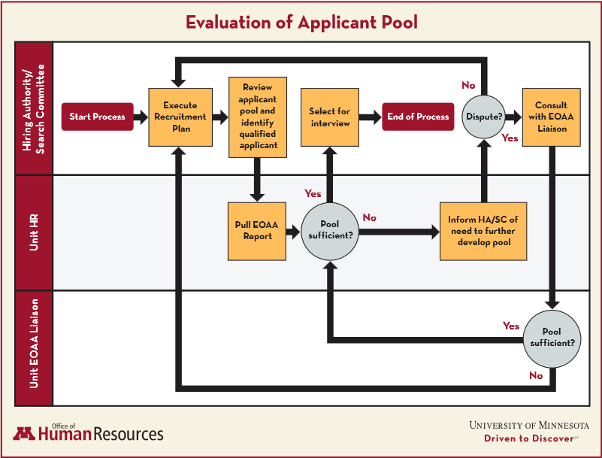

System How-To
All employees have access to Recruiting tasks through MyU. Specific access to applicant information is through a Job Opening.

Navigation
The Recruiting Home is the primary place to view and manage recruiting tasks. Links to the Recruiting Home are found MyU either by using the Manager Info tab or the Employee Center.

Manager Info:
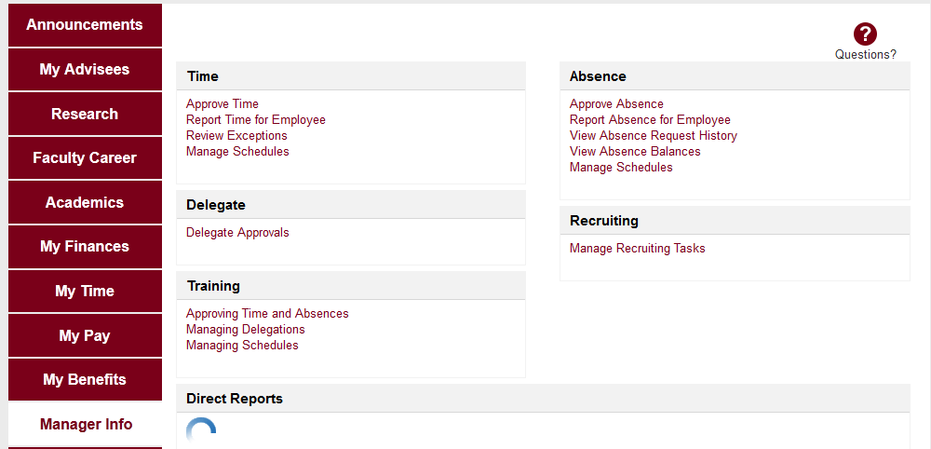

Employee Center
(Key Links > Employee Center):

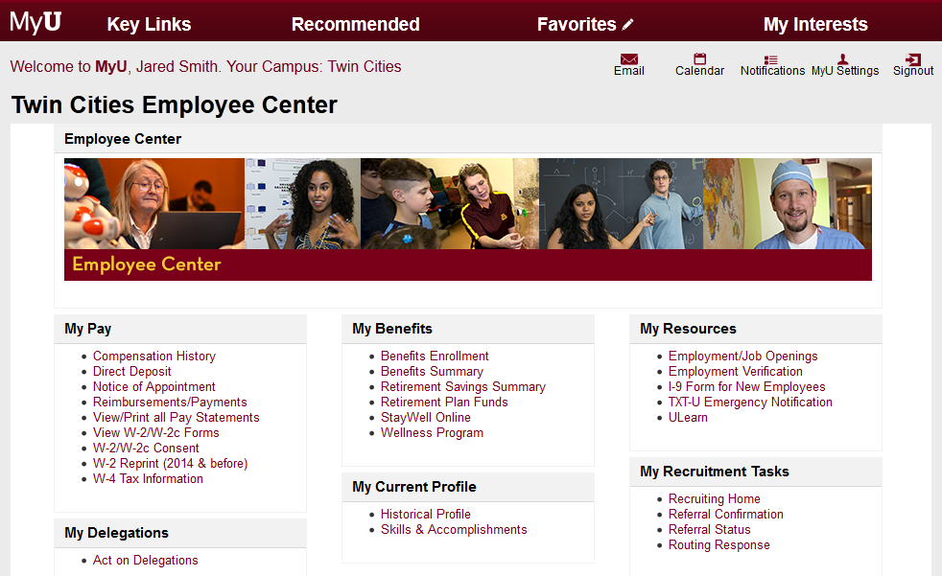

The links may be labeled differently, but both links route to the Recruiting Home in PeopleSoft 9.2. This will open in a new browser tab or window (dependent on browser settings).

Understanding the Recruiting Home
The Recruiting Home is a collection of system “pagelets” that display pertinent information to a user. The links and pagelets that display will depend on the user’s security access in the system. Most Search Committee members will only have one Recruiting role in the system, and the Recruiting Home will look like this:

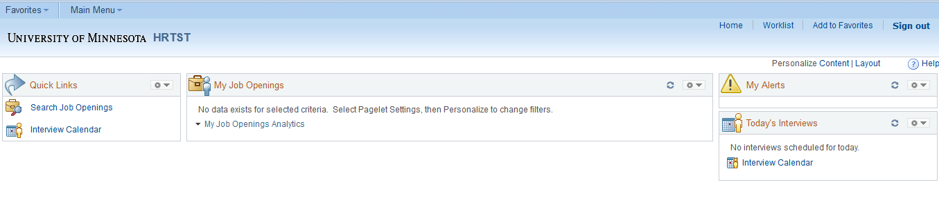

Finding Job Openings
Here are a few tips and tricks that will help you to find job openings for which you are part of the committee:

1. Personalize “My Job Openings” pagelet.
Personalizing your job openings is a one-time setup. Once you have done this, you should not have to do this again. This may be useful if you serve on search committees on a regular basis.

Click the settings icon () to view the options.

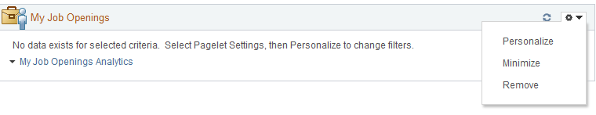
Click Personalize. The Personalize My Job Openings page will display. The display defaults to “Jobs Assigned to Me”, which is used for primary hiring managers and recruiters.

Change the display from “Jobs Assigned to me” to “All Jobs”. You may also want to update the Created Within filter to 080 – View All. Click Save after making your selections.
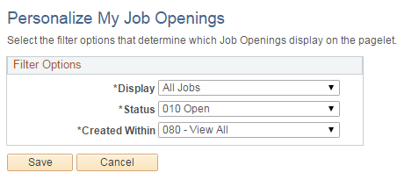

After clicking save, you will be routed back at the Recruiting Home and the My Job Openings pagelet will display all jobs that you are authorized to view.

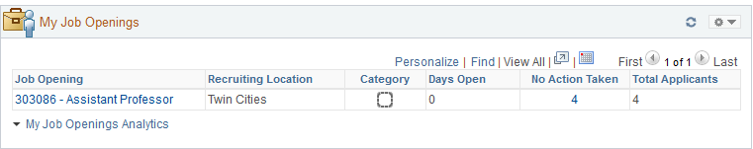

Note: You are only authorized to view job openings if you are part of the Hiring Team. This helps ensure our applicant privacy. In this example, while there are thousands of job openings available at the University, this Search Committee member only has access to this particular opening.

2. Search Job Openings
You may also find the job opening by clicking on “Search Job Openings”.
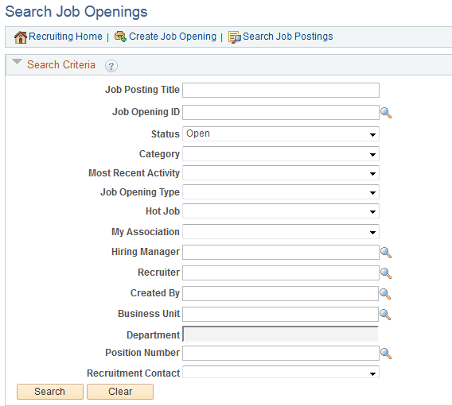

You can enter as many criteria as you would like. If you would like to view filled/closed jobs, you could change the status from Open. In this example, we will search with the criteria as displayed. Click Search to view results.

The search results will display and you can click on the Job Opening to access the information:
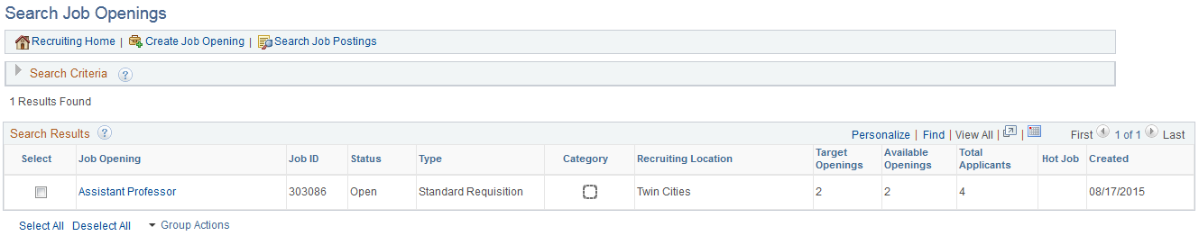

Interview Calendar
You will primarily use the Recruiting Home to access job opening and applicant information, but you may also use it to view your interview calendar.

If the interviews are set up within Recruiting, you will be able to view them by clicking on Interview Calendar.
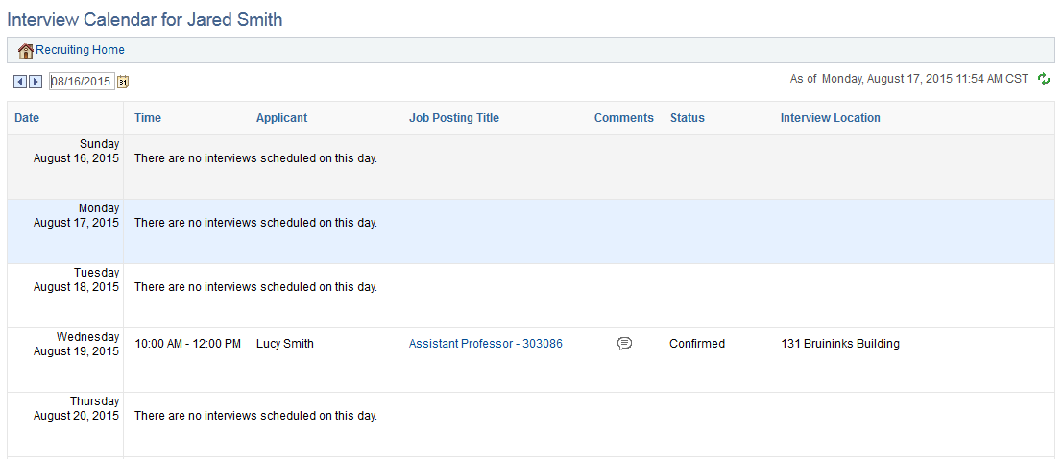

In this example, Jared is set to interview Lucy. There is a link to the Job Posting Title, so that Jared can easily find access the job opening and application information.

Manage Job Opening Page
In order to view details about the job opening and all associated application materials, you will click on the Job Opening link from My Job Openings or from your search results.

The “Manage Job Opening” page will display:
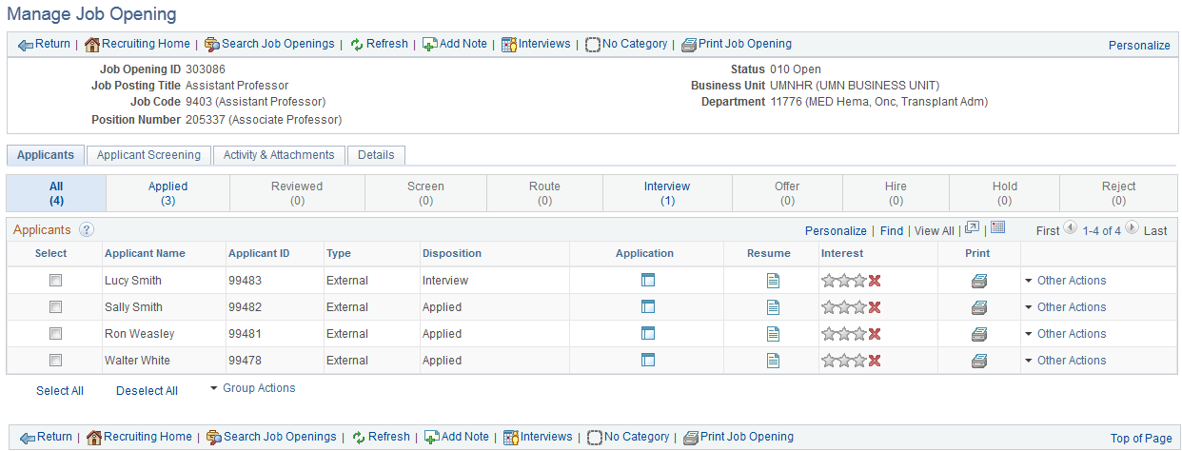

Search Committee members have “view only” access to job opening and applicant information.

Understanding Applicant Dispositions
When you first view a job opening, you will see “All” applicants. This will display applicants in any of the applicant dispositions. In the example above, you can see that Lucy Smith is in the disposition of Interview, while the other applicants are still in applied.

Applicants will move through the process from Applied to Hired. As applicants move through, Unit or central Recruiters will update the disposition to reflect the current state of the applicant. Often times, part of the search committee charge is to determine the pool of qualified applicants. This will include a comprehensive review of applicant materials against the posted qualifications of the opening. You will then work with Unit Recruiters to update the applicant disposition to reflect the committee’s decisions.

Reviewing of applicants by the search committee, for Civil Service/Bargaining Unit positions, will take place when the applicant is in the disposition of Routed. This means, they have been deemed minimally qualified by central human resources and ready for search committee review. For all other job openings, the search committee may review applicants in the applied disposition.

At any point in time, you can click on the tabs to filter your view to only see applicants in a specific disposition. You can easily see how many applicants are in each disposition in the tabs:

In this example, there are four (4) total applicants. Three (3) are in the disposition of Applied while one (1) has been moved to Interview.

The University is required to report on all qualified applicants as they progress through the hiring process. The business process states that we use the following dispositions:

Applied – all applicants who complete the application process for a specific job opening
Route – minimally qualified applicants for a specific job opening
Interview – qualified applicants who were interviewed (there may be multiple rounds of interviews, but the disposition will remain in interview until the next step in the process)
Offer – applicants who have been offered the job
Offer Accepted - applicants who have accepted an offer
Hired – applicants who were hired into the opening
Rejected – applicants who did not meet the minimum qualifications (i.e. did not ever get “routed”), or applicants who did not meet selection criteria at a later phase in the process

Other system dispositions may display, but these are the required dispositions for federal reporting.

We do not require the usage of Review or Screen as part of the Recruiting process, but some units may use this information to designate that a committee review has taken place.

Viewing Application Materials
Application materials are accessed through the Application () and Resume () icons on the applicants grid. The application will open in a new browser window or tab, so you will want to make sure that your browser allows pop-ups. The resume will download if it is a .doc file, and will open in a new window or tab if it is .pdf.

The application will include any information that the applicant entered into the system, as well as all of the attachments that the applicant provided:
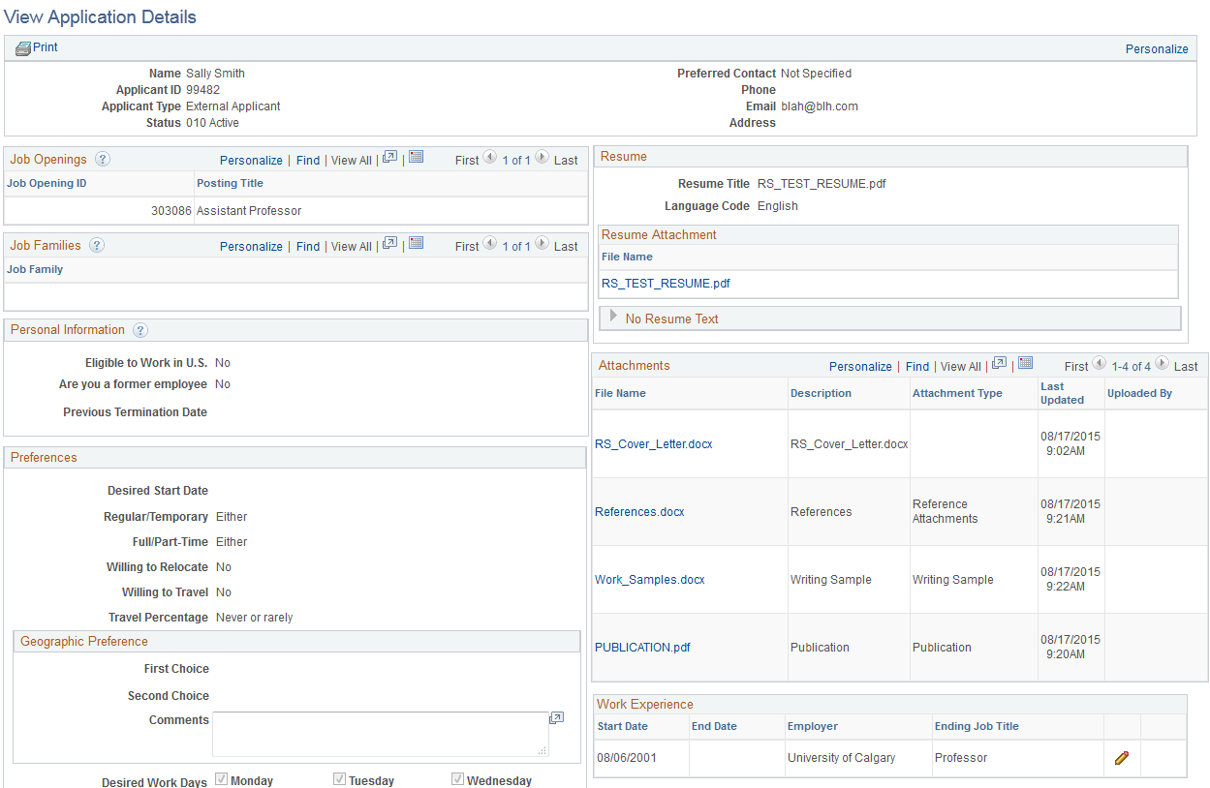

You can click on any of the attachment links to view or download the information that the applicant has provided. If the applicant entered additional information, such as work experience, simply click on the pencil () to view that information.

You may print a report of the information by clicking on the print link at the top of the page.

Use the materials that the applicant provided to help make your determination in regards to their qualifications.

Viewing Job Posting Information
You must know the qualifications of the job itself, in order to know what you are evaluating the applicant on. Some units may provide you with an electronic copy of the job description, but you may also use the Recruiting system to generate a report for yourself.

You do this by navigating to the Job Opening (through Search Job Openings or the My Job Openings pagelet) and clicking on the Print Job Opening link in the toolbar:

This will bring you to a new page, where you can select the sections that you would like to see in a report. By default, all sections are selected for you. The duties and qualifications are part of the “Job Posting” section, so if that is all that you would like to see, you could deselect all values except for Job Posting.

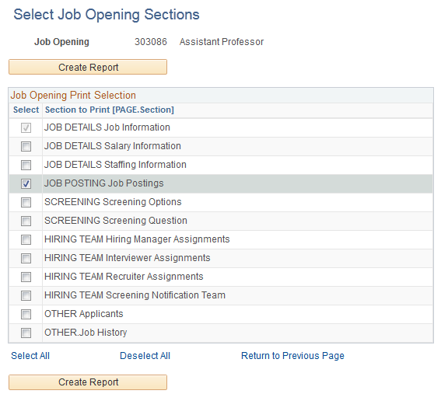
Click “Create Report” to generate the report. The report will display as a PDF in a new browser tab or window. If this does not occur, check your browser settings to ensure that pop-ups are enabled.

Examples are below:
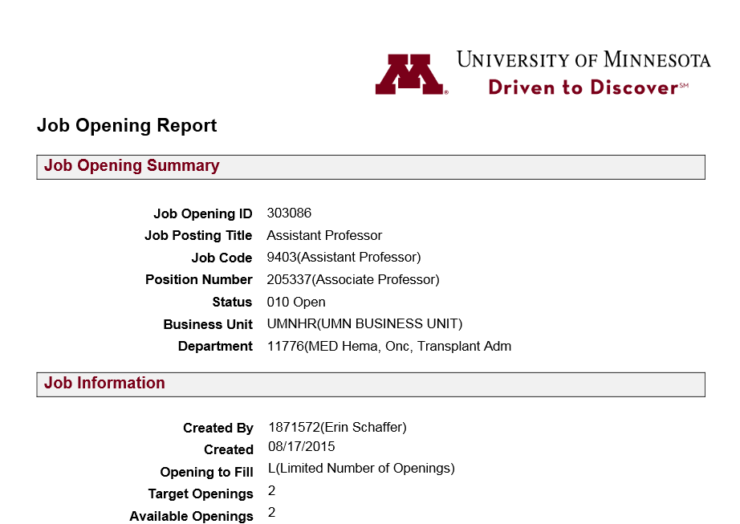

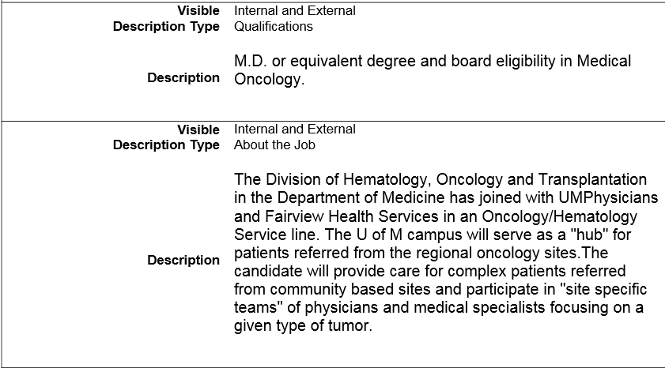

Expected Outcomes
Using this guide, you should be able to obtain the following results:
You understand the role of a search committee member
You are able to navigate to the Recruiting Home through MyU
You can view applicant materials
You can view the Job Opening report

