Instructions for completing a General Offer Letter for a Graduate Assistant Flexible Hourly Appointment.

When complete, print this letter on letterhead. Attach: (1) “Employment Terms and Conditions for University of Minnesota Graduate Assistants,” (2) Tuition Benefits Information, and (3) “Required Proof of COVID-19 Vaccination or Exemption,” and (4) Map to the building where the position is located.

Instructions for using this Template.

All fields contained within brackets [ ] are fields which require user modification. Click once on any word within the bracket and type your text. When a choice of paragraphs or sentences is given, be sure to delete the paragraph or sentence not used. If you choose not to use the template as written, be sure to include all elements in the “Required Elements” section in your letter.

[Click here and type recipient's preferred name]

Dear [Click here and type preferred name] , :

I am very pleased to offer you a graduate assistant position of () in at the University of Minnesota. This is a flexible hourly graduate assistant appointment. General information about graduate assistant appointments can be found online at https://hr.umn.edu/Jobs/Student-Job-Center/Graduate-Assistant-Employment/About-Graduate-Assistant-Employment. The legal name, address and phone number of the employer is University of Minnesota, 100 Donhowe Building, 319 15th Ave. SE, Minneapolis MN 55455; (800) 756-2363.

[If applicable, add this section] The University recognizes that your preferred name is [Click here and type preferred name] , however for the purpose of taxes and other legal documents outlined at https://z.umn.edu/LegalName we are required to include your legal name, [Click here and type legal name] , in this document.

The terms of this offer are outlined below:

- This is a flexible hourly appointment for intermittent hours to be worked during the period of through . Hours will be worked in accordance with your schedule and the needs of the department. Actual hours worked must be submitted on time cards to your supervisor biweekly.
- The mutually agreed upon start date for this appointment is . Please report to . A map has been enclosed for your convenience.
- The end date for this appointment is .
- Your hourly rate of compensation is .
- The pay period is 14 days in length and you will be paid bi-weekly (every other Wednesday). You may expect your first paycheck on .
- Your position fits one of the “Student-Employees” exemptions from the overtime provisions of the Fair Labor Standards Act and applicable Minnesota law.
- Deductions will be taken from your paycheck as required by law for federal and state income tax withholding. There will be a deduction of 6.2% for Social Security (Old-Age, Survivors and Disability Insurance) up to the applicable income limit, and 1.45% for Medicare, unless you are temporarily present in the U.S. on an F-1, J-1, M-1, and Q-1 visa, and a nonresident for income tax purposes under section 7701(b) of the Internal Revenue Code (other conditions also apply). Social Security and Medicare taxes together may be referred to as “Federal Insurance Contribution Act” or “FICA” taxes. You may elect voluntary deductions for employee benefits.
- You are not eligible for vacation benefits, but sick leave and other benefits are described here https://hr.umn.edu/Jobs/Graduate-Assistant-Employment/Graduate-Assistant-Employee-Benefits.
- A document describing tuition benefits associated with graduate assistantships is enclosed. Please note that tuition benefits do not cover student fees; you are responsible for paying all fees.
- As a graduate assistant you qualify for enrollment in the Graduate Assistant Health Insurance Plan if hours to be worked will meet a minimum of at least 195 per semester. You may pick-up an enrollment packet from your department or at the Graduate Assistant Health Insurance Office at N323 Boynton Health Service. Information may be found online at: https://shb.umn.edu/health-plans/gahp-home. You are also eligible to enroll your dependents for dependent health insurance under the same plan in which you enroll, with the University subsidizing a portion of the cost of the dependent premiums as well.
- Federal law requires that all employees be authorized to work in the United States. This employment offer is contingent upon verification that you meet this requirement. In addition, if you are here on a non-immigrant visa, you must be authorized specifically to work at the University of Minnesota. Regardless of your citizenship status, you must: 1) complete and submit Section 1 of the I-9 Form found at http://www.newi9.com on or before your first day of work for pay, 2) provide the required I-9 documentation described on the I-9 form to establish your identity and authorization to work on or before your first day of work for pay, and 3) receive confirmation from the University that your documentation satisfies the federal law requirements. Your employment, including any rights and privileges afforded under the University's codes, policies, and agreements applicable to your position, does not begin until all of these steps have been completed. If you report to your first day of work without the required I-9 documentation, you will not be allowed to start work, or remain in the workplace until you present the required documents.
- Please review the “Required Proof of COVID-19 Vaccination or Exemption” addendum and be prepared to bring acceptable proof of vaccination or completed request for exemption on your first day of employment.
- (Include when required by the Administrative Policy Background Checks and Verifications:)
This offer is contingent on the successful completion of a background check. You will receive an email from the University’s background check vendor, HireRight, that will include the link to enter your personal information and authorization for the check. Please enter your information as soon as possible after receiving the link from HireRight Customer Support.
- You are responsible for continuing to comply with any and all licensing, certification or other requirements for the position.
- You have a right to review your personnel file once every six months while employed with the University of Minnesota. To exercise this right, you must submit a written request to review your file to . If, after reviewing your file, you dispute specific information, please inform your . The University may agree to remove or revise the disputed information. After you have had an opportunity to review your file, you may make a written request for a copy of the record at no cost to you.

Below is a summary of the general position responsibilities and performance expectations for your position:

. You are required to continue to comply with all licensing, certification, work eligibility, and other requirements of the position, as set forth in the position description.

I would be happy to answer any questions you may have or provide further clarity on your appointment. Should you decide to accept this position, return the enclosed copy of this letter with your signature and date indicating that you have read and fully understand the provisions of your employment as explained above. Please proceed to make an appointment with at so that appropriate documents connected with your acceptance of this new position may be completed.

We look forward to working with you and anticipate that your employment here will be rewarding to both you and .

Sincerely,

Enc: Employment Terms and Conditions for University of Minnesota Graduate Assistants

Tuition Benefits Information
Required Proof of COVID-19 Vaccination or Exemption
Map to

cc: Employee File

I accept the position of in and the terms and conditions of employment described in this letter.

Graduate Assistant Signature |  |  | Date
Student ID Number

This document contains important information about your employment. Check the box at left to receive this information in this language.
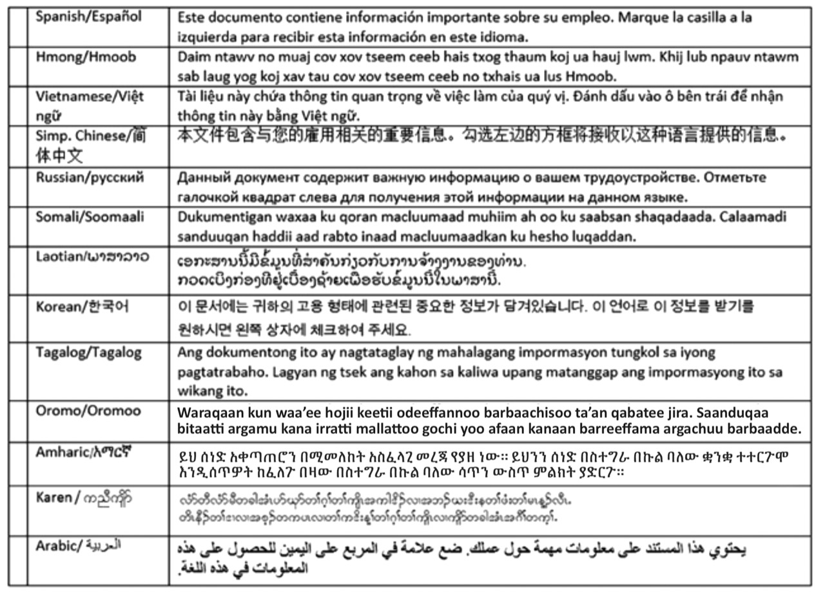

Employment Terms and Conditions for University of Minnesota Graduate Assistants

Policy and Guideline information pertaining to graduate assistantship employment is available online (https://hr.umn.edu/Jobs/Student-Job-Center/Graduate-Assistant-Employment/About-Graduate-Assistant-Employment), from your hiring department, or from Graduate Assistant Employment. Please be aware you are responsible for knowing the policies and guidelines applicable to your appointment as a graduate assistant.

In addition to the terms and conditions set forth in your graduate assistant appointment letter, graduate assistantships are contingent upon admission to the Graduate School, current registration as a graduate student and satisfactory progress toward a Graduate School degree. In order to hold a graduate assistantship during fall or spring semester you are required to be registered for credit (audit registration only is not acceptable). For regular assistantships, six credits of registration are required; for Advanced Masters and Ph.D. Candidate positions, one credit is required. If personal circumstances require registration for fewer than six credits, you may apply for an exception. For details, see the above web site. Registration during May Intersession and summer term are not required to hold an assistantship.

Registration must be completed by the end of the second week of classes and maintained for the entire semester or your graduate assistantship will be terminated. Withdrawal from all credits will result in termination of your assistantship. If your assistantship is terminated, the hiring department has the option of converting your appointment to a non-student classification for the remainder of that semester only; however, benefits such as your graduate assistant health insurance plan and tuition benefits may be adversely affected.

Tuition benefits will be available to you if you meet eligibility requirements. These benefits are summarized on the following pages. Further details may be found online (https://hr.umn.edu/Jobs/Student-Job-Center/Graduate-Assistant-Employment/About-Graduate-Assistant-Employment).

You may enroll in the Graduate Assistant Health Insurance Plan if you meet eligibility requirements. If you are interested in this coverage, you must enroll through the Graduate Assistant Health Insurance Office located at N323 Boynton Health Service, 612-624-0627.

If you have F-1 or J-1 visa status, federal law prohibits the University from employing you more than 20 hours per week (50% time) during scheduled class periods and finals weeks. Exceptions exist if you have been authorized for ‘practical or academic training.’ Consult with the Office of International Student and Scholar Services over these matters.
TUITION BENEFITS

Student Fees

Tuition benefits do not cover student fees.

Waiver of Nonresident Portion of Tuition

Graduate Assistants who work a minimum of 25% time (10 hours per week) per semester and are properly registered are eligible to receive resident rate tuition during that semester. Resident rate tuition also applies to eligible students’ immediate family members (spouse or registered same sex domestic partner, children, parents, or legal guardian or ward living in the household).

Maximum Benefits per Semester

A graduate assistant appointed 50% time (an average of 20 hours per week) for the full-semester payroll period (which begins before the start of classes and extends beyond finals week) typically receives a tuition benefit equivalent to the Graduate School’s tuition band level (at resident rates). This benefit would cover 6-14 credits per semester. Those in the Advanced Masters or Ph.D. Candidate job classes receive a benefit equal to one credit of Graduate School tuition. Legal Project Assistants with Tuition Benefits receive the equivalent of Law School tuition. Medical Fellows must work 100% time for the full semester to receive the equivalent of the Graduate School’s tuition band level.

Prorated Tuition Benefits

Graduate assistants appointed for less than 50% time or for less than the full semester payroll period will not receive the maximum tuition benefits. Their benefits are prorated according to the total number of hours worked over the 19.5 week payroll semester. Maximum benefits require appointments of at least 390 hours per semester (20 hours x 19.5 weeks). Appointments for fewer than 97.5 hours per semester (equivalent to a 12.5% appointment for the full term) do not qualify for any tuition benefit.

The tuition benefit percentage can be calculated by dividing total semester hours of employment by 390. A full-semester 25% appointment (195 hours) receives half of the Graduate School tuition band level. Full term appointments between 25% and 50% receive prorated tuition benefits, the percentage equivalent to double their appointment percentage (e.g., a 40% appointment receiving 80% tuition benefit).

Appointments Beginning After or Ending Before the Official Semester Appointment Dates

Appointments that begin after or end before the official semester appointment dates will be prorated according to total hours worked for the semester payroll period. The student will have the unearned portion of tuition benefits billed to them, at non-resident rates if applicable. If the shortened appointment falls below the 97.5-hour eligibility threshold (equivalent to a 12.5% time appointment for the full semester period), 100% of the tuition will be billed to the student, at non-resident rates.
Appointments Ending Due to Graduation

If an appointment ends early because of graduation, the student will receive the full tuition benefit awarded for that final term of employment as a graduate assistant. The benefit will not be prorated and charged back to the student.

Summer Tuition Benefits

Nine-month academic year assistantships carry no summer tuition benefit. Summer benefits are earned only from hours of assistantship employment during the 13-week summer period between spring and fall semesters. In order to provide comparable maximum benefits to those earned during an academic year semester, summer benefits accrue at a 50% faster rate; maximum benefits (typically, the Graduate School’s tuition band level) are earned for 260 hours of summer employment (i.e. 20 hours x 13 weeks) and lesser hours are prorated according to that 260 hour norm. The minimum summer appointment threshold for tuition benefits is 65 hours. Benefits are higher for the 9574 job class, Summer Session Teaching Assistant, and are calculated differently. See the GAO website (https://hr.umn.edu/Jobs/Student-Job-Center/Graduate-Assistant-Employment/About-Graduate-Assistant-Employment) for details.

Extended Waiver of Nonresident Portion of Tuition

Former graduate assistants, their immediate family members, and/or domestic partners are eligible to receive extended resident rate reductions if the graduate assistant has held at least two semesters of qualifying appointments (at least 25% time). This benefit is extended to graduate assistants who are no longer employed as graduate assistants for a maximum of four semesters, one term of extended benefit earned for each term of employment. Extended benefits must be used within three years of the last term of assistantship appointment.

Provisional Tuition Benefits

A department may place a graduate assistant on a provisional appointment (flexible hourly) whereby the assistant may receive a tuition benefit at the beginning of the semester based upon an estimation of the number of hours the assistant will work per week. The department shall submit the actual number of hours worked by the assistant at the end of the semester to Graduate Assistant Employment. Any hours worked in excess of the estimated number will result in a tuition benefit credit, if applicable. If fewer hours are worked than the estimated number, the student will be billed for the unearned portion of tuition benefits, at non-resident rates if applicable. If the total number of hours worked per semester falls below the 12.5% time minimum eligibility requirement (97.5 hours) in order to receive a tuition benefit, the student will be billed for the entire tuition benefit received, at non-resident rates if applicable.

Required Proof of COVID-19 Vaccination or Exemption

To comply with the University’s Administrative Policy: COVID-19 Vaccination and Safety Protocol Requirements for University Employees and Student Workers, on your first day of employment you must submit documentation as follows:

- Proof that at least 14 days have passed after administration of a single dose of the Janssen/Johnson & Johnson vaccine, or 14 days have passed after administration of the second dose of any other acceptable COVID-19 Vaccine; OR
- A completed request for an exemption using either the medical exemption form or religious exemption form.

Acceptable COVID-19 Vaccines are those approved or authorized for use by the U.S. Food and Drug Administration or World Health Organization to prevent COVID-19. Vaccines meeting this definition currently include Pfizer-BioNTech (Comirnaty, Tozinameran), Moderna (Spikevax), Janssen/Johnson & Johnson, AstraZeneca/Oxford (Vaxzevria), Bharat Biotech/Covaxin, Serum Institute of India/Covishield, Sinopharm/Beijing (Covilo), and Sinovac/CoronaVac.

Acceptable proof of vaccination includes the following documentation:

- A digital image of the covered individual’s completed CDC COVID-19 Vaccination Record Card (must be the card provided by the medical provider or pharmacist that administered the shot(s)); OR
- A digital image of the covered individual’s record of COVID-19 vaccination from the Minnesota Department of Health Minnesota Immunization Connection (MIIC) or another official state immunization information system. Covered Individuals can link to this system using the Docket app, which is available for multiple phone and computer platforms; OR
- A digital image of the Covered Individual’s record of COVID-19 vaccination prepared by the health care provider or pharmacy that administered the shot(s)

