P&A Appointment Letter Checklist
An appointment letter for a P&A position must include each of the following provisions:
- The pursuant’s preferred name. If applicable, also include the following statement: The University recognizes that your preferred name is [preferred name], however for the purpose of taxes and other legal documents outlined at https://z.umn.edu/LegalName we are required to include your legal name, [legal name], in this document.
- University job title and corresponding job code.
- Working job title, if different from the University job title.
- Employee ID.
- Specific University of Minnesota college/campus/administrative unit and, if applicable, department/division for this position.
- Statement that the legal name, address and phone number of the employer is University of Minnesota, 100 Donhowe Building, 319 15th Ave. SE, Minneapolis MN 55455; (800) 756-2363.
- The name of the person to whom the position reports.
- Whether the appointment is an academic professional or academic administrative position.
- Length of probationary period (optional at the discretion of the responsible administrator and only applicable for multiple year academic professional positions).
- Percent time of appointment.
- Annual renewable, fixed term, temporary, multiyear?
- Length of appointment (e.g., 9 months, 10 months, 12 months).
- Actual beginning and end dates of the appointment (Note: assignment of an end date for P&A staff is often not known, and a letter of non-renewal would be issued as appropriate).
- Employee can view electronic Notice of Appointment in the My Info tab of MyU. Notice should be consistent with the terms of this appointment letter.
- Policies governing position, found in the University Policy Library.
- Salary (Actual Annual Base determined by percent time and length of appointment).
- If the appointment is for a 12-month term, include the statement “Please note that you are appointed to a 12 month contract for an annual amount of pay. Your pay is delivered to you bi-weekly, divided by the number of pay dates in the contract period.”
- Statement that the position fits the Executive, Administrative, Professional, and/or Computer exemption from the overtime provisions of the Fair Labor Standards Act and applicable Minnesota law.
- Statement that the pay period is 14 days in length and the employee will be paid bi-weekly (every other Wednesday). The first paycheck will be issued on [Click here and type date].
- Statement that the employee is covered by the Faculty Retirement Plan, and may also qualify for health, dental and life insurance programs. A summary of benefits that are tied to this position may be viewed on the web at https://hr.umn.edu/Jobs/Applicant-Center/About-Working-U/Benefits-Summaries-Prospective-Employees.
- Statement that deductions will be taken from the employee’s paycheck as required by law for federal and state income tax withholding. There will be a deduction of 6.2% for Social Security (Old-Age, Survivors and Disability Insurance) up to the applicable income limit, 1.45% for Medicare and 5.5% for the Faculty Retirement Plan. The employee may elect voluntary deductions for employee benefits.
- Statement that this appointment may provide vacation benefits as described here https://policy.umn.edu/hr/academicvacation
- Statement that this appointment may provide medical leave benefits as described here https://policy.umn.edu/hr/medicaldisability
- General position responsibilities and performance expectations.
- If appropriate, whether the job offer is contingent on something, e.g., approval by the Board of Regents, etc.
- Federal law requires that all employees be authorized to work in the United States. This employment offer is contingent upon verification that you meet this requirement. In addition, if you are here on a non-immigrant visa, you must be authorized specifically to work at the University of Minnesota. Regardless of your citizenship status, you must: 1) complete and submit Section 1 of the I-9 Form found at http://www.newi9.com on or before your first day of work for pay, 2) provide the required I-9 documentation described on the I-9 form to establish your identity and authorization to work on or before your first day of work for pay, and 3) receive confirmation from the University that your documentation satisfies the federal law requirements. Your employment, including any rights and privileges afforded under the University's codes, policies, and agreements applicable to your position, does not begin until all of these steps have been completed. If you report to your first day of work without the required I-9 documentation, you will not be allowed to start work, or remain in the workplace until you present the required documents.
- Please review the “Required Proof of COVID-19 Vaccination or Exemption” addendum and be prepared to bring acceptable proof of vaccination or completed request for exemption on your first day of employment. [Make sure to include the “Required Proof of COVID-19 Vaccination or Exemption” addendum to the offer package.]
- This offer is contingent on the successful completion of a background check. You will receive an email from the University’s background check vendor, HireRight, that will include the link to enter your personal information and authorization for the check. Please enter your information as soon as possible after receiving the link from HireRight Customer Support.
- Indicate that employee must continue to comply with any and all licensing, certification and other requirements of the position.
- Right to review the employee's personnel file once every six months while employed with the University of Minnesota. To exercise this right, the employee must submit a written request to review their file to the unit HR contact. If, after reviewing the file, the employee disputes specific information, he/she should inform their unit HR contact. The University may agree to remove or revise the disputed information. After the employee has had an opportunity to review their file, he/she may make a written request for a copy of the record at no cost to the employee.
- Other items or monies being provided and the terms of provision (e.g., relocation expenses, computer, laboratory, professional development funds).
- Statement that the employee is encouraged to visit the University’s New Employee website https://hr.umn.edu/Welcome-New-Employees to explore a variety of resources for new employees. For parking and transportation information, refer to https://www.pts.umn.edu or call (612) 626-7275.
- Signature of authorized hiring authority.
- Signature of the employee accepting the term and conditions of the position as described in the letter.
- Include the following statement and graphic:
This document contains important information about your employment. Check the box at left to receive this information in this language.
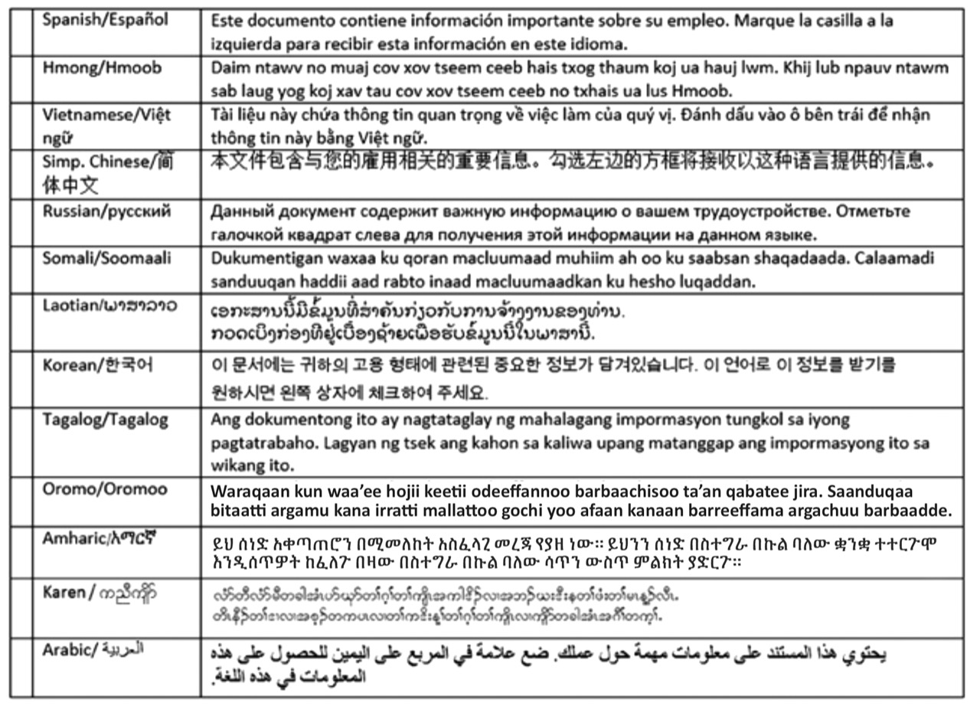

Additional information for individuals appointed on a probationary (H)/Continuous (G) appointment track:
- Performance expectations referencing the criteria by which the employee will be evaluated for continuous appointment.
- If probationary (H) appointment, reference Appendix B: Administrative Guidelines, Criteria, and Procedures for Review of Probationary (H) Academic Professionals Considered for Continuous (G) Appointment.

